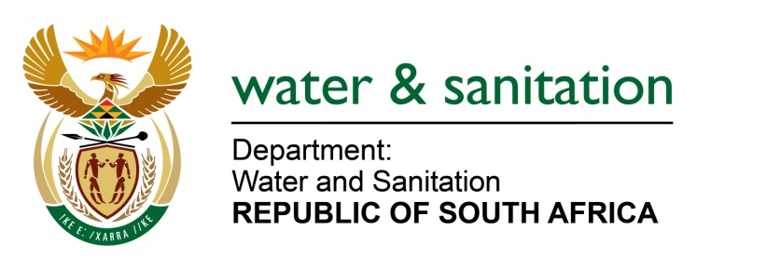

NATIONAL ASSEMBLY

FOR WRITTEN REPLY

QUESTION NO 1814

DATE OF PUBLICATION IN INTERNAL QUESTION PAPER: 9 SEPTEMBER 2016
(INTERNAL QUESTION PAPER NO. 27)

1814. Mr L J Basson (DA) to ask the Minister of Water and Sanitation:
(1) (a) When did the pipeline project between the Craigieburn Dam and Greytown in KwaZulu-Natal start and (b) what is the (i) budgeted cost of the specified project and (ii) distance of the pipeline;
(2) whether the specified project has been completed; if not, (a) why not, (b) when will it be completed, (c) what is the cost of the project to date and (d) what is the total estimated completion cost of the project; if so, on what date was the specified project completed;
(3) did the specified project go out on tender; if not, why not; if so, (a) what are the names of the companies that made submissions for the specified tender and (b) what is the name of the company that was awarded the specified tender? NW2122E
---00O00---
REPLY:

(1)(a) The pipeline project between the Craigieburn Dam and Greytown in KwaZulu-Natal started on 24 March 2015.

(1)(b)(i) The budgeted cost of the project was R203 802 607 including escalation, contingencies and VAT.

(1)(b)(ii) The distance of the pipeline is 35.0km

(2)(a) The project has not been completed due to poor performance of the three contractors appointed in the project which resulted in termination of the contracts.

(2)(b) It will take about eleven (11) weeks to complete the outstanding scope of the works. The actual start and completion dates will be negotiated between uMzinyathi District Municipality and the prospective replacement contractors once appointed through Section 32 of the Municipal Supply Chain Management Regulations.

(2)(c) The cost of the project to date is R79 493 188.

(2)(d) The total estimated cost to complete the project is R138 647 000.

(3) Yes, the project went out on tender.

(3)(a) The companies that made submissions for the specified tender are as follows:
Bankuna Engineering | V. Bhengu Construction
Sizabonke t/a Pilcon Projects | Moray & Dickson Construction
Shula Construction | Nongafa Construction
Igugulabafazi Developments | Soundrite Construction
JMngcwango Trading | Valente Bros (Pty) Ltd
Barleda 65 cc JV Busizwe | Ntandoyami JV
Velakude Trading JV Ugwadule Trading | R&B Pipelines JV Sikoti
TBA Construction | Blue Dot G Services
F&A Civils | Thembalethu Civils
Anvisba Civils | Lenong Azishe JV
WK Construction | Velekude JV Umzuzu cc
Cycade Pipelines | AM Pomolong JV
WBHO Construction | Tshenolo Resources JV Kufiki
Namandla Roads & Civils | Esor Construction
Cerimele Construction | Phumi JV Ishishini
Zanamanzi Services

(3)(b) The pipeline was broken into three contracts, and the contractors awarded the tenders were Soundrite Construction, Bankuna Engineering and Phumi/Ishishini JV.
---00O00---

