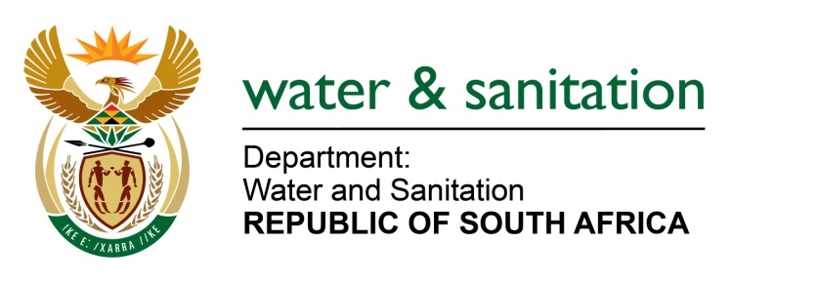

NATIONAL ASSEMBLY

FOR WRITTEN REPLY

QUESTION NO 1813

DATE OF PUBLICATION IN INTERNAL QUESTION PAPER: 9 SEPTEMBER 2016
(INTERNAL QUESTION PAPER NO. 27)

1813. Mr L J Basson (DA) to ask the Minister of Water and Sanitation:
(1) (a) When was the raising of the wall of the Hazelmere Dam in KwaZulu-Natal approved, (b) what is the (i) approved budget and (ii) cost of the project to date, (c) when will the specified project be completed and (d) what is the expected completion cost of the specified project;
(2) did the specified project go out on tender; if not, why not; if so, (a) what are the names of the companies that made submissions for the specified tender and (b) what is the name of the company that was awarded the specified tender? NW2121E
---00O00---
REPLY:
(1)(a) The project was approved as a Government water work on 8 June 2010.
(1)(b)(i) The approved budget is R593 million.
(1)(b)(ii) The Expenditure as at August 2016 is R233 million.
(1)(c) The expected completion date is January 2018 (revised per programme).
(1)(d) The expected completion cost is R620 million (revised).
(2) Yes, the project went out on tender.
 | BIDS RECEIVED
1. | Bicacon PTY/Mapitsi Civils/Setheo Consortium & SinoHydro Joint Venture (JV)
2. | Lubbe Construction
3. | Aveng Grinaker
4 | Basil Read LTD/  Rodio Consortium
5. | MRC – DSB Consortium
6. | Group Five Coastal (PTY) LTD
(2)(a) Below are the names of the companies that made submissions for the tender:

(2)(b)

The name of the company that was awarded the tender is Group Five Coastal (PTY) LTD.
---00O00---

