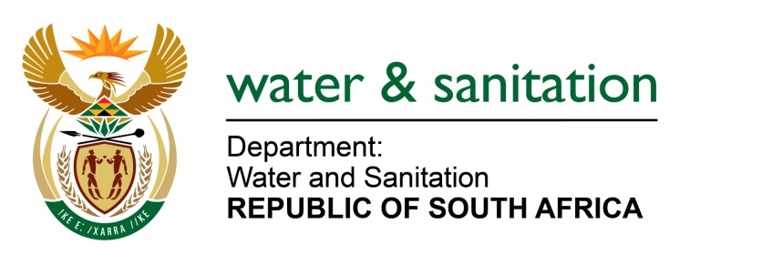

NATIONAL ASSEMBLY

FOR WRITTEN REPLY

QUESTION NO 1812

DATE OF PUBLICATION IN INTERNAL QUESTION PAPER: 9 SEPTEMBER 2016
(INTERNAL QUESTION PAPER NO. 27)

1812. Mr L J Basson (DA) to ask the Minister of Water and Sanitation:
- Whether her department had any unspent budget funds at the end of the 2015-16 financial year; if not, what is the position in this regard; if so, (a) what was the amount of unspent budget funds at the end of the specified financial year and (b) what amount of unspent funds, if any, did she request the National Treasury to roll over;

- Whether the National Treasury approved the roll-over of any unspent funds; if not, why not; if so, what amount?
---00O00---

REPLY:

(1) My Department did have unspent budget funds at the end of the 2015-16 financial year.

(1)(a) My Department has recorded an under expenditure of R189.558 million for the 2015-16 financial year.

(1)(b) Of the reported under expenditure of R189.558 million, my Department had requested to rollover funds from 2015-16 financial year to 2016-17 financial year in an amount of R77.448 million.
(2) National Treasury did not grant approval to the Department’s request for rollover of funds as it has been deemed that the Department can accommodate the related expenditure within the existing baselines.
---00O00---

