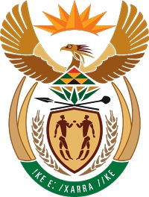
MINISTRY
COOPERATIVE GOVERNANCE AND TRADITIONAL AFFAIRS
REPUBLIC OF SOUTH AFRICA

NATIONAL ASSEMBLY
QUESTION FOR WRITTEN REPLY
QUESTION NUMBER 181
DATE OF PUBLICATION: 10 FEBRUARY 2022

181. Dr N V Khumalo (DA) to ask the Minister of Cooperative Governance and Traditional Affairs:

(a) What number of supplier invoices currently remain unpaid by (i) her department and (ii) each entity reporting to her for more than (aa) 30 days, (bb) 60 days, (cc) 90 days and (dd) 120 days, (b) what is the total amount outstanding in each case and (c) by what date is it envisaged that the outstanding amounts will be settled? NW185E

COOPERATIVE AND GOVERNANCE REPLY:

The table below indicate the status of the Payment of invoices in the Department of Cooperative Governance (DCoG) and its Entities:
ENTITY | What number of supplier invoices currently remain unpaid by (ii) each entity | (aa) More than 30 days | (bb) more than 60 days | (cc) more than 90 days | (dd) more than 120 days | (b) total amount o/s  R’00 | (c) what date the o/s amount will be settled  R’00
DCOG | None | None | None | None | None | None | Not applicable
MDB | None | None | None | None | None | None | Not applicable
SALGA | 49 | -R12 227 308.26 credit balance | R 195 549.08 with a debit balance | R 590 318.57 with a debit balance | 547 690.79 | R 1 333 558.44 | 28 February 2022
SACN | None | None | None | None | None | None | Not applicable
MISA | None | None | None | None | None | None | Not applicable
TRADITIONAL AFFAIRS | None | None | None | None | None | None | Not Applicable

