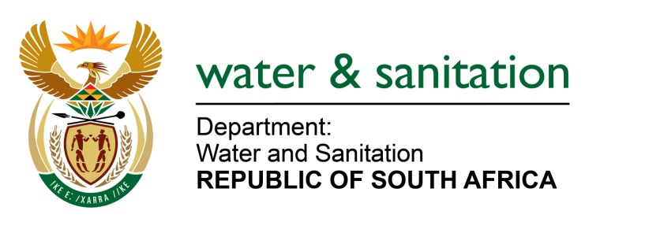

NATIONAL ASSEMBLY

FOR WRITTEN REPLY

QUESTION NO 1809

DATE OF PUBLICATION IN INTERNAL QUESTION PAPER: 19 MAY 2023
(INTERNAL QUESTION PAPER NO. 18)
1809. Mrs M R Mohlala (EFF) to ask the Minister of Water and Sanitation:
(a) How is his department addressing instances where municipalities are failing in their duties in water services provision and (b) what are the details of the legal framework being utilised where municipalities fail in their mandate to ensure compliance in terms of wastewater and effluent spillages?
NW2033E
---00O00---
MINISTER OF WATER AND SANITATION
- The Department of Water and Sanitation (the Department) works together with the Department of Cooperative Governance and Traditional Affairs (COGTA) and the South African Local Government Association (SALGA) to ensure that municipalities receive the necessary support and grant funding to refurbish and maintain water and sanitation assets. Water Service Authorities (WSAs), through their Municipal Infrastructure Grant (MIG), allocate funding for refurbishment of some of Wastewater Treatment Works (WWTW). Depending on availability of funds, the Department also funds WWTW refurbishment and upgrade projects that meet the criteria of the Regional Bulk Infrastructure Grant (RBIG) and Water Services Infrastructure Grant (WSIG).

- The Department ensures protection of water resources, which can be achieved by initiating rectification measures against the identified non-complaint water users and polluters. When municipalities fail in their mandate to ensure compliance in terms of wastewater and effluent spillages, various legal frameworks can be initiated to address the contraventions.
In instances where a water user fails to comply with any of the license conditions, the Department first exercises administrative enforcement actions in the form of Notices and Directives in accordance with the National Water Act. This is meant to afford the water users an opportunity to rectify non-compliances within certain timeframes.
When users are non-responsive, the Department proceeds with either or both criminal and civil enforcement actions. Criminal sanctions can also be instituted against the municipalities guided by Criminal Procedure Act on violations related to wastewater and effluent spillages. Section 151 of the National Water Act provides legal basis for laying of criminal charges against the municipalities that are intentionally or negligently pollute water resources or engage in unlawful water usage. Offenses under Section 151 of the National Water Act can be used to address pollution of water resources, making it a criminal offense to discharge pollutants into water resources without the necessary authorisation.
---00O00---

