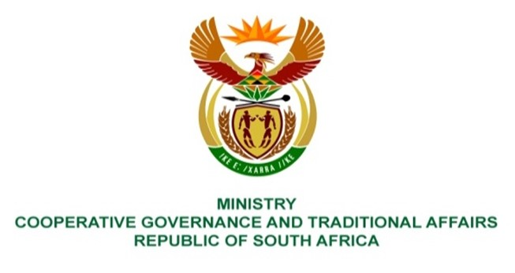
NATIONAL ASSEMBLY
QUESTIONS FOR WRITTEN REPLY

QUESTION NUMBER 2021/1809
DATE OF PUBLICATION: 20 AUGUST 2021

1809. Ms H O Mkhaliphi (EFF) to ask the Minister of Cooperative Governance and Traditional Affairs:
QUESTION:

What action has her department taken against the Councilors and/or municipalities that have been found guilty through forensic investigations in terms of section 106 of the Municipal Systems Act, Act 32 of 2000?

REPLY:

Most of the forensic reports instituted in terms of Section 106 of the Local Government Municipal Systems Act, Act 32 of 2000 made recommendations that certain remedial or other corrective measures should be taken. In instances where corruption, fraud and related offences have been identified, such reports are handed over to law enforcement agencies for further processing. Where Councilors are implicated and internal disciplinary processes are recommended, disciplinary processes are instituted in line with schedule 1 of the Local Government Municipal Systems Act.

The outcome of the assessment in some of the forensic investigations reports points to the need for further investigations. The Department continues to collaborate with law enforcement agencies, provinces and municipalities to ensure that recommendations which emanates from forensic investigation reports are implemented.

