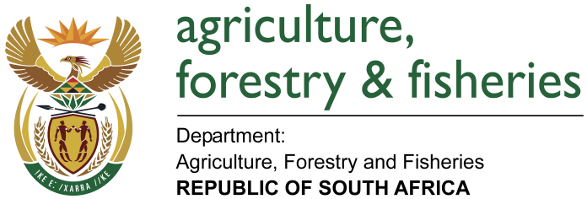
NATIONAL ASSEMBLY

WRITTEN REPLY

QUESTION 1809 / NW 1968E

MINISTER OF AGRICULTURE, FORESTRY AND FISHERIES:
Mr D J Maynier (DA) to ask Minister of Agriculture, Forestry and Fisheries:

QUESTION:
(1) Whether (a) his spouse and/or (b) an adult family member accompanied him on any official international trip (i) in each of the past five financial years and (ii) since 1 April 2018; if not, what is the position in this regard; if so, what (aa) is the name of the person(s), (bb) was the (aaa) purpose and (bbb) destination of the trip and (cc) was the (aaa) total cost and (bbb) detailed breakdown of the costs of the accompanying person(s) to his department;
(2) whether each of the specified trips were approved by the President in terms of the provisions of Section 1, Annexure A of the Ministerial Handbook; if not, why not; if so, what are the relevant details? NW1968E
REPLY ATTACHED:

