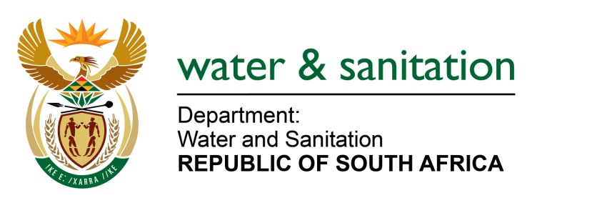

NATIONAL ASSEMBLY

FOR WRITTEN REPLY

QUESTION NO 1808

DATE OF PUBLICATION IN INTERNAL QUESTION PAPER: 19 MAY 2023
(INTERNAL QUESTION PAPER NO. 18)
1808. Mrs M R Mohlala (EFF) to ask the Minister of Water and Sanitation:
Whether he is still considering the establishment of the Independent Economic Regulator for setting of water tariffs; if not, (a) why not and (b) what is the alternative; if so, what are the relevant details?
NW2032E
---00O00---

MINISTER OF WATER AND SANITATION
In August 2022, the Minister established a Regulatory Commission comprising of eleven (11) Commissioners who, as a collective panel of experts, possess various sets of economics, financial, social and technical qualifications and experience. The Commission was established in terms of Section 99 of the National Water Act and serves as the Minister’s advisors and provides a level of autonomy in improving the transparency and predictability in regulatory decision making.
The Minister is of the view that this regulatory model needs to be given a chance. Therefore, the required legislative provisions were made in the revised draft National Water Act to empower this Commission.
---00O00---

