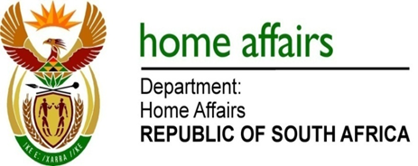

NATIONAL ASSEMBLY

QUESTION FOR WRITTEN REPLY

QUESTION NO. 1807

DATE OF PUBLICATION: Friday, 9 September 2016

INTERNAL QUESTION PAPER 27 OF 2016

1807. Mr M H Hoosen (DA) to ask the Minister of Home Affairs:

(1) Whether (a) he and/or (b) the Government have taken any steps since 1 January 2013 to ensure that South Africa re-joins the United Kingdom’s visa waiver list; if not, why not; if so, (i) how many times has (aa) he and/or (bb) the Government met with the British authorities to discuss the re-joining of the specified list and (ii) what were the outcomes in each case;
(2) whether (a) he and/or (b) the Government have conducted any assessments regarding the specified re-joining since 1 January 2013; if not, why not; if so, what are the relevant details?
NW2115E
REPLY:

(1)(a-b) On 10 September 2013 the 10th SA-UK Bilateral Forum was held in Cape Town. At this meeting the two parties agreed that the United Kingdom would send a UK experts group to access South Africa’s passport and border security processes. The honourable Minister of International Relations and Cooperation, Ms Maite Nkoana-Mashabane co-chaired the meeting with Britain’s then Foreign Secretary, Mr William Hague. This meeting was followed up by eight Senior Officials meetings, three of which took place in 2013, two in 2015 and three in 2016.

During the 2013 meetings the UK authorities informed the South African counterparts of its intention to review their visa policy towards South Africa. It was agreed that a road map be developed for the lifting of visa restrictions for South African diplomatic and official passport holders. This was followed by a UK experts team assessment of South African passport issuance and border management processes, which assessment recognised the improvements made by South Africa.

The 2015 meetings focussed on the United Kingdom seeking response from South Africa on their decision to lift visa restrictions for South African diplomatic passport holders. South Africa’s response was that we would only consider reciprocity if the United Kingdom lifted visa restrictions for all South African passport holders.

The 2016 meetings concerned the continuing requests for the lifting of visa restrictions for all South African passport holders. The UK counterparts are now awaiting the new government’s visa policy where after they will inform the South African authorities accordingly.

(2)(a-b) All efforts made to engage the British government to understand the rationale behind its decision or to at least reconsider by exempting South African diplomatic and official passport holders were in vain.

