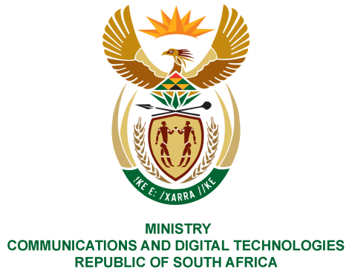

PARLIAMENT OF THE REPUBLIC OF SOUTH AFRICA

NATIONAL ASSEMBLY

WRITTEN REPLY

QUESTION NO: 180
DATE OF PUBLICATION: 10 FEBRUARY 2022
QUESTION PAPER NO: 01
Mr H C C Krüger (DA) to ask the Minister of Communications and Digital Technologies:
(a) What number of supplier invoices currently remain unpaid by (i) her department and (ii) each entity reporting to her for more than (aa) 30 days, (bb) 60 days, (cc) 90 days and (dd) 120 days,
(b) What is the total amount outstanding in each case and
(c) By what date is it envisaged that the outstanding amounts will be settled?

NW184E
REPLY:
I have been advised by the Department and entities as follows:

DEPARTMENT:
- Currently there are no invoices that are unpaid by the Department for,

- N/A.

- N/A

ENTITIES:
(a)
ENTITY | (aa) 30 days | (bb) 60 days | (cc) 90 days | (dd) 120 days
SITA | 51 | 40 | 28 | 91
NEMISA | None | None | None | 5
BBI | 35 | 95 | 24 | 9
SENTECH | 7 | 2 | 4 | 20
FPB | 1 | 1 | 2 | 1
SABC | 23 | 19 | 9 | 2
ZADNA | None | None | None | None
SAPO | 90 | 26 | 17 | 63
POSTBANK | 1 | 2 | - | 5
ICASA | 18 | 11 | 03 | 29
USAASA | 6 | 6 | 2 | 3

(b)
ENTITY | 30 days | 60 days | 90 days | 120 days
SITA | R45.3m | R45.3m | R45.3m | R45.3m
NEMISA | - | - | - | R70 364.74
BBI | R13 000 942 | R19 100 028 | R17 089 078 | R12 338 747
SENTECH | R267,606.64 | R267,606.64 | R267,606.64 | R267,606.64
FPB | R 7 854.20 | R 737 420.63 | R 456 499.72 | R318 279.37
SABC | R1 152 514.02 | R24 421 343.05 | R 1 973 703.05 | R191 242. 27
ZADNA | - | - | - | -
SAPO | R119m | R59m | R37m | R270m
POSTBANK | R136 967,30 | R141 107,14 | - | R10 672 890.74
ICASA | R371 859,95 | R366 837,92 | R19 946,55 | R175 127.05
USAASA | R419 193.21 | R441 369.37 | R107 308.27 | R29 090.64
(c)

SITA is working with all its client departments to ensure that they make funds available to settle all outstanding invoices as soon as possible, not later than 31 March 2022. These outstanding amounts are largely for services consumed by different government departments, and SITA manages the related contracts on their behalf, and can only settle invoices when client departments make funds available.
NEMISA envisage that the outstanding amount will be settled by 31 March 2022.
BBI stated that; (30 days) 29 of these invoices (R2 615 956) have since been paid. The balance of the invoices is from fellow SOE’s with whom they are discussing payment options. (60 days) 70 invoices (R162 783) are from their previous Travel Management Company and still undergoing verification. The balance of the invoices is from fellow SOE’s with whom they are discussing payment options. (90 days) the invoices are from two fellow SOE’s with whom they are discussing payment options. (120 days) the invoices are from two fellow SOE’s with whom they are discussing payment options.
SENTECH stated that the outstanding amounts will be settled by 31 March 2022.
FPB indicated that the envisaged date of settlement is by 31 March 2022 for all invoices that meet the payment requirement i.e. Service or Goods have been delivered.
.ZADNA indicated they have no outstanding amount to be settled.
SABC invoices falling between 30-120 days will be settled between February 2022 and March 2022 subject to all internal processes being concluded.
SAPO currently does not have the required funds to settle the liabilities. SAPO has requested funding through the MTEF process. SAPO has developed a revised strategy to improve its operational and financial performance and is in the process of implementing such. However, the success of the new Strategy depends on the availability of funding.
Postbank has indicated that the payment will be made by 28 February 2022, with the exception of SAPO where payments to SAPO were put on hold as SAPO has withheld Postbank's revenue from SASSA on payment of grants. Negotiations between SAPO and Postbank are still in progress. The outcome of these negotiations will determine the way forward.
ICASA stated that invoices falling between 30 – 90 days are currently in progress and will be settled no later than the end of February 2022. The invoices falling within the 120 days are either under dispute or the supplier’s tax status is not up to date, therefore payment cannot be effected.
USAASA has indicated that some of the invoices will be paid before end of February 2022, while other invoices are awaited to be are fully compliance.

MS. NONKQUBELA JORDAN-DYANI
DIRECTOR-GENERAL (ACTING)
DATE:

Recommended/not recommended

__________________________
HON. PHILLY MAPULANE, MP
DEPUTY MINISTER OF COMMUNICATIONS AND DIGITAL TECHNOLOGIES
DATE:

Approved/ not approved

________________________________
HON. KHUMBUDZO NTSHAVHENI, MP
MINISTER OF COMMUNICATIONS AND DIGITAL TECHNOLOGIES
DATE:

