NATIONAL ASSEMBLY

QUESTION FOR WRITTEN REPLY
PARLIAMENTARY QUESTION NO. 18
DATE OF QUESTION: 20JUNE2019

DATE OF SUBMISSION: 4 JULY 2019
Adv G Breytenbach (DA) to ask the Minister of Justice and Correctional Services:
What (a) number of court intermediaries are currently employed by his department in each province, (b) court(s) do the intermediaries serve, (c) number of cases do the intermediaries attend to each month and (d) languages are the intermediaries proficient in?
NW975E

REPLY
- What number of court intermediaries is currently employed by the department in each province?
In the 2014/15 financial year, the Department created 185 permanent posts of court intermediaries and 9 permanent posts of Assistant Director (ASD) Intermediaries. The periodical recruitment process commenced in the 2015/16 financial year, and by the 2017/18 financial year, the Department had filled 179 of 185 posts of court intermediaries and 5 of 9 posts of ASD Intermediaries. However, due to the declining economy, austerity measures in budget allocations are persistently introduced, and in effect, constraining the Department’s plan to fill the remaining vacant posts. The current demand on social work services in the country has also resulted in the exodus of many intermediaries to better opportunities. As at 31 March 2019, the number of court intermediaries in permanent posts declined from 179 to 153, while the numerical capacity of the ASD intermediaries dropped from 5 to 4.
In bridging intermediary service gaps at our courts, the Department has recently introduced an automated Intermediary Diary Management System to ensure the shared use of the intermediaries within provinces and beyond. Through this system, the existing pool of intermediaries can be accessed by any court in the country, as and when the need arises, to match the special needs of the victim, often relating to language, age, disability, etc.
In strengthening further the existing human capital in intermediary services, the Department also utilises a pool of ad hoc intermediaries- mostly drawn from the NGO sector. This intervention also assists in relieving the pressure of unemployment in the country. In certain provinces, there are social workers employed by the Department of Social Development (DSD) who are released to assist, whenever the demand arises. The Table below gives a numerical spread of these services over all provinces in the country:
Province | DoJ&CD Intermediaries as at 31 Mar 2019 |  |  | DSD Intermediaries | Total
 | Court Intermediaries | Assistant Director Intermediaries | Ad Hoc Intermediaries
Eastern Cape | 16 | 1 | - | - | 17
Free State | 10 | - | 3 | 2 | 15
Gauteng | 12 | 1 | 27 | 16 | 56
KwaZulu-Natal | 34 | - | 1 | 2 | 37
Limpopo | 17 | 1 | - | - | 18
Mpumalanga | 14 | - | 2 | - | 16
Northern Cape | 9 | - | - | - | 9
North West | 18 | 1 | - | 2 | 21
Western Cape | 23 | - | 3 | 2 | 28
Total | 153 | 4 | 36 | 24 | 217

- What courts do the intermediaries serve?
In terms of section 170A of the Criminal Procedure Act, 1977 (Act No 51 of 1977), intermediary services are offered in any criminal proceedings pending before any court where it appears to such court that such proceedings would expose any witness under the biological or mental age of 18 years to undue mental stress or suffering if such witness testifies without support. Among all witnesses appearing in criminal proceedings held at our courts in the country, only children and persons with mental disabilities are entitled to intermediary services. Likewise, section 61(2) of the Children’s Act, 2005 (Act No 38 of 2005) also require the use of intermediary services when children testify in proceedings held in terms of this Act.
At present, intermediaries are spread over and shared between regional criminal courts and children’s courts, where the demand for this service is predominantly high. As at 31 March 2019, the country has 405 regional criminal courts of which 89 are the sexual offences courts. The childrens’ courts are operating at 309 magisterial district courts and some at the 332 branch/ periodical courts. Intermediaries also service our high courts, whenever the need arises. Currently, in South Africa there are 11 high court divisions with 5 local seats. As indicated, the service of intermediaries is subject to demand and may therefore not be a daily occurrence at a given court.
- What number of cases do the intermediaries attend to each month?
The Department uses the Integrated Case Management System (ICMS) for Intermediary Services to collect data from our courts. Currently, this system collects data of intermediary services offered at regional criminal courts and the children’s courts, where the demand for these services is currently highly concentrated. The statistics are collected in terms of people who receive these services and not in accordance to the cases registered at our courts. The plan is to increase the functionality of the ICMS and extend its scope to other cases. During the period of 12 months (i.e. 1 April 2018 to 31 Mar 2019) intermediaries rendered services to 14 907 children and 261 persons with mental disabilities who appeared in sexual offences and children’s courts proceedings held nationwide. The Table below gives the spread of these services over provinces per annum:
CASES WHERE INTERMEDIARY SERVICES WERE RENDERED: 2018/2019
Province | Sexual Offences |  |  |  | Children’s court
 | Child Witnesses | Child Victims | Mentally Disabled Witnesses | Mentally Disabled Victims | Witnesses | Victims | Total
EC | 787 | 1 894 | 3 | 105 | 43 | 62 | 2 894
FS | 451 | 890 | 1 | 5 | 54 | 64 | 1 465
GP | 603 | 2 114 | - | 9 | 16 | 20 | 2 762
KZN | 392 | 1 912 | 2 | 51 | 5 | 16 | 2 378
LIMP | 269 | 640 | 6 | 15 | 21 | 23 | 974
MP | 329 | 1 150 | 1 | 13 | 11 | 11 | 1 515
NW | 198 | 585 | 1 | 11 | 61 | 30 | 886
NC | 216 | 715 | 1 | 16 | 39 | 19 | 1 006
WC | 340 | 915 | 4 | 17 | 4 | 8 | 1 288
TOTAL | 3 585 | 10 815 | 19 | 242 | 254 | 253 | 15 168

The demand for the intermediary services differs from court to court and from month to month. In each month there are about 1 000 eligible persons who receive these services nationwide. Monthly statistics is only available in services rendered to child victims of sexual offences. Below is the number of child victims of sexual offences who received intermediary services per month in the 2018/ 19 financial year.
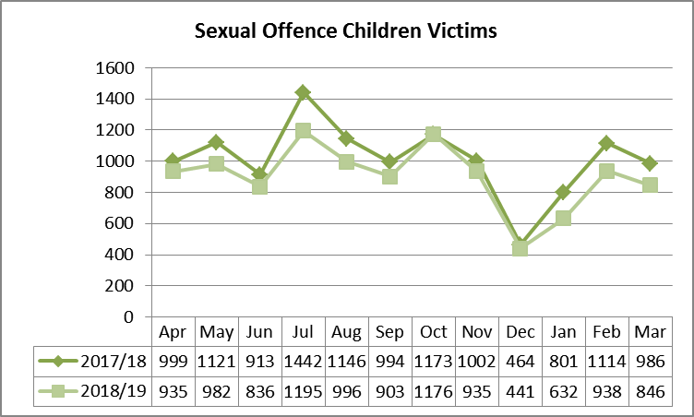
- What languages are the intermediaries proficient in?
Intermediaries are appointed on the basis of proficiency in the language predominantly used at the courts they would be stationed at. With the recent introduction of the automated Intermediary Diary Management System, intermediaries are now booked for cases in accordance with the language needs of the victim/ witness and are shared throughout the country. This system is intended to avoid the unnecessary postponement of cases due to language shortages. Services are offered in all 11 official languages. For persons requiring sign language, ad hoc intermediaries are used. Below is a matrix showing language utilisation in each province:
Province | English | Afrikaans | Setwana | Sesotho | Isizulu | Siswati | Isixhosa | Isindebele | Tshivenda | Sepedi | Xitsonga
EC | 216 | 70 | 1 | 27 | 50 | 0 | 257 | 5 | 0 | 0 | 1
FS | 37 | 25 | 12 | 76 | 11 | 0 | 16 | 0 | 0 | 0 | 1
GP | 116 | 73 | 72 | 84 | 172 | 6 | 89 | 9 | 17 | 77 | 33
KZN | 209 | 9 | 0 | 11 | 275 | 0 | 74 | 0 | 0 | 0 | 1
LIMP | 84 | 4 | 15 | 12 | 17 | 8 | 1 | 7 | 14 | 97 | 24
MPUM | 55 | 10 | 5 | 6 | 63 | 39 | 0 | 23 | 0 | 44 | 11
NC | 58 | 34 | 94 | 25 | 7 | 0 | 3 | 1 | 1 | 12 | 2
NW | 55 | 97 | 75 | 0 | 0 | 0 | 22 | 0 | 0 | 1 | 1
WC | 115 | 147 | 1 | 0 | 2 | 0 | 103 | 0 | 0 | 0 | 0
TOTAL | 945 | 469 | 275 | 241 | 597 | 53 | 565 | 45 | 32 | 231 | 74

