Ref:02/1/5/2

MINISTER

QUESTION NO. 1799 FOR WRITTEN REPLY: NATIONAL ASSEMBLY

A draft reply to Mr T Z Hadebe (DA) to the above-mentioned question is enclosed for your consideration.

MS NOSIPHO NGCABA
DIRECTOR-GENERAL

DATE:

DRAFT REPLY APPROVED/AMENDED

DR B E E MOLEWA, MP
MINISTER OF ENVIRONMENTAL AFFAIRS

DATE:
NATIONAL ASSEMBLY
(For written reply)

QUESTION NO. 1799 {NW1958E}
INTERNAL QUESTION PAPER NO. 19 of 2018

DATE OF PUBLICATION: 01 June 2018

Mr T Z Hadebe (DA) to ask the Minister of Environmental Affairs:
(1) What is the status of the ambient air quality in the South Durban eThekwini Municipality area?
(2) has there been any recent health impact study undertaken by her department in the area; if not, why not; if so, what were the findings thereof;
(3) what (a) are the details of the strategy that has been put in place to (i) address the findings of the specified study and (ii) improve the air quality in the area and (b) is the role played by the licensing authority in addressing the cumulative impact of air pollution in the area;
(4) whether she will provide Mr T Z Hadebe with the (a) minutes of the Air Quality Officers forum, (b) air quality management plan and (c) allocated budget for air quality management; and
(5) whether her department is considering an intervention on account of health risks posed; if not, why not; if so, what are the relevant details?
1799. THE MINISTER OF ENVIRONMENTAL AFFAIRS REPLIES:
(1)
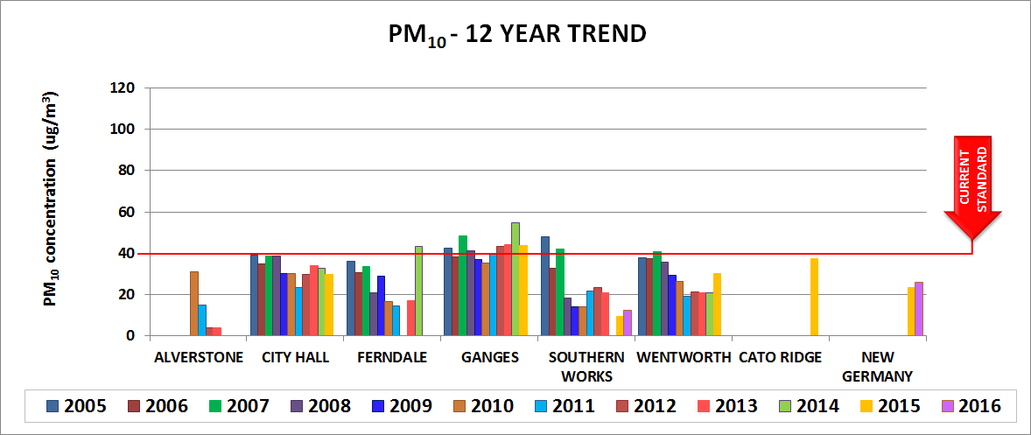
Ambient air quality has been monitored at 14 stations in the EThekwini Municipality for 12 years to date. A range of pollutants are measured. Two stations, Southern Works and Wentworth are located in the South Durban Basin. Since 2008, particulate matter concentrations at these stations have come down and are now in compliance with South Africa national ambient air quality standards. Ganges ambient monitoring station, which falls outside the basin, is however in non-compliance with particulate matter ambient standards, and this is mostly due to the vehicle emissions from the busy Southern Freeway close to this station.
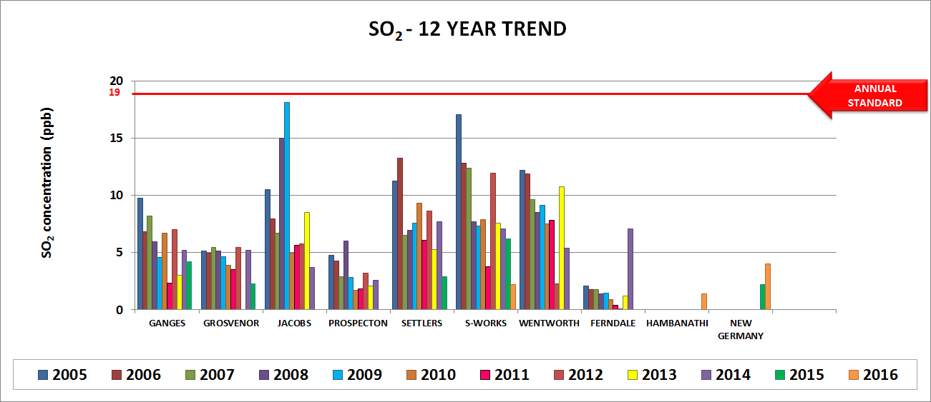
In terms of sulphur dioxide, the three stations in the basin, namely, Settlers, Southern Works and Wentworth have also reported significant decreases in the sulphur dioxide annually over the years. The reduction in pollution seen in most stations since 2008 to 2010 over eThekwini are as a result of regulatory interventions such as the Scheduled Trade Permitting system and Atmospheric Emission Licensing programs implemented by the city, to target industrial emissions within the South Durban Basin.

(2) Health studies require special scarce skills and are relatively expensive to undertake. In the recent years, the Department of Environmental Affairs has spent over 8 Million Rands on health studies. Unfortunately, for financial reasons, the department has to prioritise study areas to focus on at a given time. To date, the Department has completed a health study in the Vaal Triangle Priority area. The department is currently conducting a health study in the Highveld Priority Area (HPA). In addition to being costly, these studies also takes time to complete. The current HPA health study will only be completed in late 2019, and only after then can the Department consider other priority areas. In the meantime, provinces and municipalities are encouraged to conduct local health studies.

A South Durban Health study was conducted in 2007 to determine the health status of the Durban South residents with specific focus on respiratory diseases and to determine an association between these diseases and environmental pollution. The study also assessed the range of ambient air pollutants to determine the potential risk they pose on the health of the Durban South community. The study revealed that moderate ambient concentrations of nitrogen dioxide (NO₂), nitric oxide (NO) sulphur dioxide (SO₂) and PM₁₀ were strongly and significantly associated with decrements in lung function among children with persistent asthma and/or polymorphism associated with the ability to respond to oxidative stress. Children attending school in the south of Durban as compared to the north, were significantly associated with the increased risk of persistent asthma and for marked airways hyper reactivity. For adults, residing in the south was significantly associated with hayfever and marginal associated with chronic bronchitis, wheeze, shortness of breath and hypertension.

In addition, a joint Health study was completed in the early 2000’s. This study included National, Provincial, and the Local sphere of government as well as academia, industry and international partners. The primary intervention post the study was to reduce the levels of SO₂ in the area as this pollutant is a known trigger for asthma. Significant reductions for this pollutant have been achieved. The eThekwini Municipalities AQMP which has a five year life span has included a further Health study in the financial year 20/21. This will need to include multiple stakeholders as the municipality could not fund a study of this nature in isolation.
(3)(a) Since the study, a number of interventions have been deployed at national, provincial and municipal level. Below are just a few.
- A tightening of controls on large industrial emitters with specific reference to SO2, Benzene, NOx and PM.
- The Department of Environments Affairs developed Minimum Emission Standards to control industrial emissions. The notice in this regard was published in 2010 and finalised in 2013. There were no previous standards in this regard and this promulgation and this allows for far tighter regulation of industries. Regulatory air quality management including the assessment of all new developments by means of Specialist Studies together with the Licensing of all Listed Activities as defined in NEM; AQA (39 of 2004) have resulted in an improvement in the air quality in the area.
- Enforcement inspections are being conducted to ensure compliance with the legislation and that conditions of the atmospheric emission licenses are adhered to.
- Continuous monitoring of criteria pollutants to determine if the national ambient air standards are not exceeded. Since then there has been some improvements as shown below:

(b) is the role played by the licensing authority in addressing the cumulative impact of air pollution in the area:
- The licensing authority continue to monitor the industry to ensure that they adhere to conditions of the atmospheric emissions licenses.
- Cumulative impacts are generally considered during the approval of new developments. This is often approached by the introduction of specialist studies conducted during the EIA process

(4) The minutes of the AQO forum can be obtained from the Provincial Air Quality Officer at the provincial department responsible for environmental affairs.

(5) The intervention for addressing air pollution and therefore reducing the health risks posed are stipulated in the eThekwini Metro’s air quality management plan (AQMP). According to the said AQMP, the eThekwini Municipality Health Study is planned for 20/21. The National Department will support this process.

---ooOoo---

