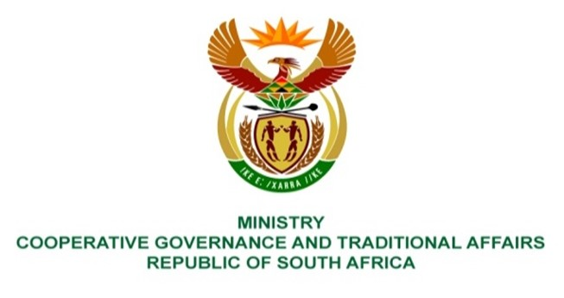

NATIONAL ASSEMBLY
QUESTION FOR WRITTEN REPLY

DATE OF PUBLICATION: 19 MAY 2023

1794. Ms P Madokwe (EFF) to ask the Minister of Cooperative Governance and Traditional Affairs:
a) How far is her investigation into the corruption that happened in AB Xuma Local Municipality which saw millions of Rands meant to build a stadium being misused and (b) why has it taken so many years for the investigation to be concluded and those implicated held accountable? NW1815E
REPLY:
The response below was provided by the Department of Cooperative Governance and Traditional Affairs in the Eastern Cape province. Accordingly, I have been advised as follows:

(a) The MEC established a team to investigate the allegations at Dr AB Xuma Local Municipality. The team visited the municipality to conduct an investigation from 11 to 15 July 2022, and conducted interviews with relevant officials; analysed documentation and obtained evidence. A report was thereafter prepared for consideration by the MEC.

(b) Limitations in terms of the scope of the investigation caused delays in the investigation. Due to the fact that most of those implicated are no longer with the municipality, the office of the MEC referred the matter to the South African Police Service (SAPS), to allow SAPS to deal with the matter.
End.

