# NATIONAL ASSEMBLY

**FOR WRITTEN REPLY**

**QUESTION NO. 1794**

**DATE OF PUBLICATION IN INTERNAL QUESTION PAPER: 20 AUGUST 2021**

**(INTERNAL QUESTION PAPER NO. 17)**

**Ms M D Hlengwa (IFP) to ask the Minister of Health:**

Whether, with reference to reports that the Delta variant has affected a lot of children in the United States of America resulting in overcrowded paediatric wards, his department has made the relevant preparations to ensure that the Republic does not face a similar predicament; if not, why not; if so, what are the full, relevant details?

###### NW2011E

**REPLY:**

According to the reports from the DATCOV, in South Africa, children make up a smaller proportion of those tested for SARS-CoV-2, confirmed cases, hospital admissions and in-hospital deaths, despite comprising 37% of the population. The picture here below shows the low rate of infections among children including the data for the third wave, which is why the department has adopted an attitude of alert and caution on the infection and admission rate of children.

Figure 1: Incidence risk of SARS-CoV-2 cases per 100,000 persons, by age group and epidemiologic week, South Africa, 5 March 2020-14 August 2021

**Hospital admissions**

The records from the DATCOV show that Covid-19 hospitalisation rate is low among children in all three waves, compared to adults. However there was a 44% increase in admissions in children <19 years, in 3rd wave compared to the 1st wave peak. Among individuals under 19 years, the highest rate of hospitalization is in children < 1 year. The reasons for this increased admission is likely testing for non-COVID indications, because clinicians were likely admitting them as a precaution in this younger population group.

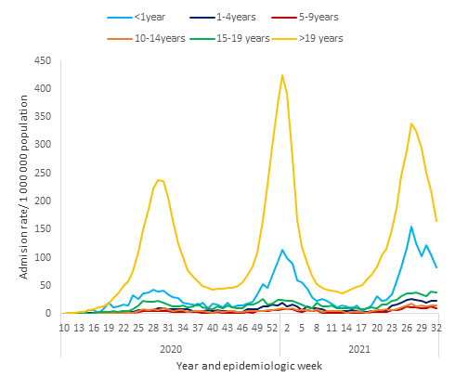

Figure 2: Incidence risk of COVID-19 admissions per 100,000 persons, by age group and epidemiologic week, South Africa, 5 March 2020-14 August 2021

Although there have been slightly more children admitted during the third wave compared to the first, the delta virus doesn't seem to be causing more severe infections in children. It is for this reason that it is unlikely that paediatric hospital bed capacity and critical care capacity will be overwhelmed as has been seen in adults.

Despite these low numbers, the health system has made adequate provision for the increased hospitalisations for all age groups during all various waves of Covid-19 pandemic. With the information having come to our attention, the health system will pay special attention to this possibility during the review of the implementation of the third wave resurgence plans, which will include planning for the fourth wave.

Of the 11 129 COVID-19-associated admissions among individuals aged ≤19 years, 688 (6.2%) were admitted into ICU and 252 (2.3%) were ventilated at some point during admission. Children are generally managed in line with the guidelines on Covid in Children contained in the National Essential Medicine List Standard Treatment Guidelines. A more detailed guideline (Managing Maternal, Neonatal and Child Health during the COVID-19 pandemic in South Africa: A clinical guide for health workers and clinical managers) provides additional detail. Children and adolescents with mild disease should be managed at home, whilst those with moderate or severe disease should be admitted in the health facilities. From the previous waves, it has been shown that children and adolescents rarely required admission to ICU.

The public sector has approximately 11,000 paediatric beds and 3,000 neonatal beds (DHIS data). To date there has been sufficient capacity to accommodate the additional workload resulting from the Covid-19 pandemic. Adolescent beds are generally only available in central hospitals, with the result that many adolescents are cared for in adult wards in most hospitals, which are in good supply. Whilst the number of adolescents requiring admission and ICU care in particular remains small, these numbers have been included when planning for surge capacity during all waves.

Afrox, as the service provider for oxygen supply and support, has made provision for all means of supply ranging from different kinds of cylinders to the reticulated bulk oxygen supply. This includes coverage of paediatrics wards.

END.