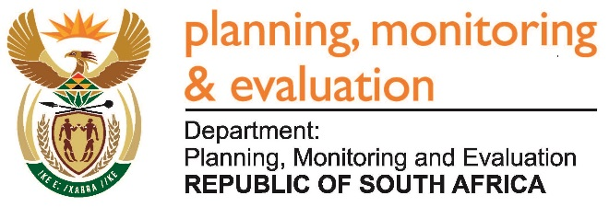 |  | 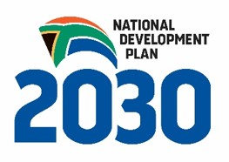
Private Bag X944, PRETORIA, 0001. Union Buildings East Wing, Government Avenue, PRETORIA
Tel: 012 312 0307. www.dpme.gov.za
1793. Ms M O Mokause (EFF) to ask the Minister in The Presidency:
(1) Which entities reporting to him (a) have a board in place and (b) do not have a board in place, (i) of those that have a board, (aa) when was each individual board member appointed and (bb) when is the term for each board lapsing and (ii) how many (aa) board members are there in each board and (bb) of those board members of each entity are female;
(2) with reference to entities that do not have boards in place, (a) who is responsible for appointing the board and (b) when will a board be appointed? NW2001E
REPLY
The NYDA Board was appointed by the President on 5 May 2017 for a period of three years. It consists of seven members, of which three are females.
Statistics South Africa does not have a Board. It has a Statistics Council which is provided for in the Statistics Act, No.6 of 1999.

