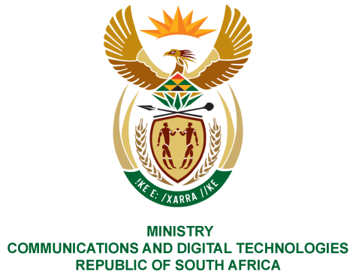
PARLIAMENT OF THE REPUBLIC OF SOUTH AFRICA

NATIONAL ASSEMBLY

WRITTEN REPLY

QUESTION NO: 1792
DATE OF PUBLICATION: JULY 2020
QUESTION PAPER NO: 29

Ms P T van Damme (DA) to ask the Minister of Communications:
Whether (a) her department and (b) all entities reporting to her paid out the remainder of contracts to employees whose employment was terminated before the contractually stipulated date of termination in the past two financial years up to the latest specified date for which information is available; if not, why not; if so, what total amount has been paid out in each case?

REPLY
I have been advised by the Department and Entities as follows:

Department of Communications and Digital Technologies:
- The department did not have early termination of contracts for the past two financial years.

ENTITIES:

SENTECH

(b) Sentech did not terminate any of its fixed term contracted employees over the last two financial years 2018/19 and 2019/20, neither did it pay out settlements over the stated periods.

NEMISA

(b) At NEMISA, during the financial year 2018/2019, 2019/2020 and 2020/2021 all employees on contract, were not terminated before the contractually stipulated date of termination. Therefore, there were no pay-outs during these financial years.

BBI

(b) In the past two financial years no employee of Broadband Infraco (BBI) left the company before the contractually stipulated date of termination of their contract of employment. As a result, the company has not paid out any monies for the remainder of a contract to any employee.

ICASA

Not Applicable. ICASA did not have any such cases within the last two financial years.

SABC

- Not applicable. The SABC did not pay out any employees whose fix term contracts were terminated before they came to an end in the last two financial years.

USAASA

(b) Mr Musa Ngidi, Executive Manager: Corporate Services was suspended on 1 June 2017; and dismissed on 30 September 2018. CCMA awarded his reinstatement retrospectively to 30 September 2018, with effect 01 October 2019, as well as paying his salary for the period that he was dismissed. Mr Ngidi entered into negotiations with the Agency that instead of him coming back to office, he be rather paid the remainder of his contract. Four (4) months instead of Six (6) months was agreed upon as a period to be settled as the remainder of his contract.

Payment in the amount of R2 180 453.00 (Two Million One Hundred Eighty Thousand Four Hundred And Fifty-Three Rand) which comprises of the following was paid out:

R1 189 338.00 awarded by the Commissioner for the period Sep 2018 to Oct 2019;
R594 669. 00 for the period Oct 2019 – Mar 2020;

R396 446.00 for termination of contract including all statutory costs, including but not limited to leave pay; and any other cost, including but not limited to interest.

Legal costs to review application incurred by Mr Ngidi in the amount of R25 000.00
(Twenty-Five Thousand Rand);

The above-mentioned amounts, except the legal costs, were subjected to SARS Tax
Directive and taxed before being paid to Mr Ngidi.

FPB

(b)The Film and Publication Board (FPB) did not terminate any of its fixed term contracted employees, over the last two financial years 2018/19 and 2019/20, neither did it pay out any settlements over the stated periods

SAPO

(b) Not applicable, SAPO did not pay out any employees whose fixed term contracts were terminated before they came to an end in the last two financial years.

POSTBANK

Not Applicable. Postbank did not have any such cases within the last two financial years.

ZADNA

- Not applicable, ZADNA did not pay out any employees whose fixed term contracts were terminated before they came to an end in the last financial years.

SITA

b) Mr Louis Mark Schlebush was on a 2-year contract that was due to expire later in the current financial year ended on 09 April 2020. He was implicated in the NMMU project where amongst other things, he allegedly colluded with external suppliers. He was suspended and later charged, however, to continue with the case, the organization relied on evidence from external OEM’s who were not willing to testify. Based on the broken trust relationship between the organisation and the employee, a mutual separation agreement of three months was entered into. He was paid an amount of R564 300, 00 before tax.

Ms Sibongile Jabulile Tlhako was the Executive: Supply Chain Management. Her contract terminated on 05 August 2018. She was suspended and charged on allegations of poor management of contractors and other irregularities in the Supply Chain Environment. Upon receiving the charges, she requested to get into mutual separation agreement with the organization, which the then CEO approved at 3 months to avoid the costs of a lengthy litigation. The decision was also taken to ensure that the organization could speedily appoint a replacement considering the significance of the SCM division within SITA. She was paid an amount of R291 710, 04 before tax.

Mr Johnson Mzuvakile Dyodo’s case related to conflict of interest and procurement irregularities. During the disciplinary hearing proceedings, the parties came to an agreement to mutually separate on the basis of broken trust relationship. He was therefore paid his salary for the month of termination and an additional month’s salary as notice period. Her contract was terminated on 31 July 2018 and paid an amount of R468 187, 32.

Ms Fikiswa Njongwe was dismissed on 31 July 2017 following forensic investigations. She challenged the case at CCMA which resulted in an award in her favour including interest of what was owed. The legal department filed for a review at the labour court, however, was advised to rather engage in a settlement with Ms Njongwe. The settlement was made on June 2020 and the amount that was eventually negotiated and paid out was R1 m lower than the CCMA award. She was paid an amount of R1 521 716, 69.

MS. STELLA NDABENI-ABRAHAMS, MP
MINISTER OF COMMUNICATIONS AND DIGITAL TECHNOLOGIES

