36/1/4/1(201800193)
NATIONAL ASSEMBLY

FOR WRITTEN REPLY

QUESTION 1788

DATE OF PUBLICATION IN INTERNAL QUESTION PAPER: 1 JUNE 2018 (INTERNAL QUESTION PAPER NO 19-2018)

1788. Mr M Bagraim (DA) to ask the Minister of Police:

- What is the current (a) actual and (b) optimal number of police officers involved with sector policing at the Tembisa South Police Station;

- by what date will the specified police station receive its full complement of
sector police officers?
NW1945E
REPLY:

(1)(a)(b) and (2)

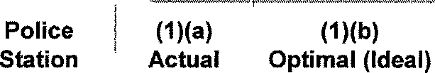
(2)

Tembisa South Sector Policing
Date when full complement will
be reached
During the 2017/2018 financial year, one student was allocated to the police station. The entry level allocation demand was submitted to

24 59 (-35)
the National Commissioner and once the allocation is received, priority will be given to police stations, in order to address shortages and fill the projected service terminations.

Reply to question 1787 recommended/ e

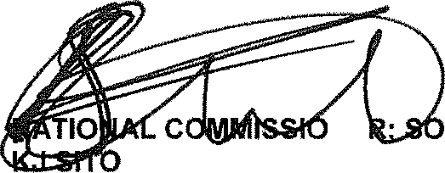
GENERAL
NE
LE (SOEG)
UTH AFRICAN POLICE SERVICE

Date: j§]g -g$• (I 8

2

Reply to question 1787 approved/n

MINIST OF POLICE BH CELE, MP

