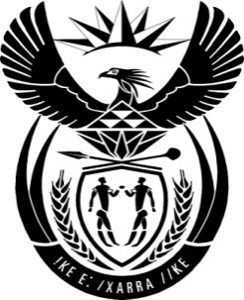

THE PRESIDENCY: REPUBLIC OF SOUTH AFRICA
Private Bag X1000, Pretoria, 0001
NATIONAL ASSEMBLY
QUESTIONS FOR WRITTEN REPLY

QUESTION NO: 1788

Date Published: 31 July 2015
The Leader of the Opposition (DA) to ask the President of the Republic:
What discussions were held between him and the President of the Russian Federation, Mr Vladimir Putin and/or any other Russian Federation government official during his visit to the specified country in May 2015?
NW2007E

Reply:
On 09 May 2015, I undertook a working visit to the Russian Federation at the invitation of Russian President Vladimir Putin, to attend the 70th Anniversary of Victory in the Great Patriotic War of 1941-1945 (WWII). The visit was guided by South Africa’s bilateral relations with the Russian Federation, which are informed by political, economic, social, defence and security cooperation and all the relevant legal instruments and mechanisms that affirm the strategic relationship between the two countries.

We held talks on the margins of the event which included an assessment of bilateral cooperation, the status and implementation of SA-Russia ITEC (Joint Intergovernmental Committee on Trade and Economic Cooperation) Agreements and preparations for the 13th SA-Russia ITEC Session to be hosted by the Russian Federation during the latter part of 2015.

We also discussed preparations for the 7th BRICS Summit which was hosted by Russia from 08 to 09 July 2015. We agreed on the need to intensify cooperation in various areas of cooperation.

