FOR WRITTEN REPLY

QUESTION 1787

NATIONAL ASSEMBLY
36/1/4/1(201800192)

DATE OF PUBLICATION IN INTERNAL QUESTION PAPER: 1 JUNE 2018 (INTERNAL QUESTION PAPER NO 19-2018)

1787. Mr M Bagraim (DA) to ask the Minister of Police:

- What is the current (a) actual and (b) optimal number of police officers involved with sector policing at the Edenvale Police Station;

- by what date will the specified police station receive its full complement of sector police officers?
NW1944E
REPLY:

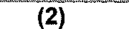
(1)(a)(b) and (2)

Date when full complement will be reached
During the 2017/2018 financial year, one student was allocated to the police station. The entry level allocation demand was submitted to the National Commissioner and once the allocation is received, priority will be given to police stations, in order to address shortages and fill the projected service terminations.
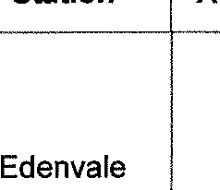
Police
Station
(1)(a) (1)(b)
Actual Optimal (Ideal)
Edenvale Sector Policing
31
35 (-4)

Reply to question 1787 recommended/

LE (SOEG)

Date: " " " '

GENERAL UTH AFRICAN POLICE SERVICE

2

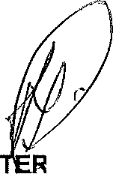
Reply to question 1787 approved/not approved

MINIS : OF POLICE BH CELE, MP

Date:

