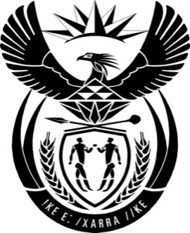

THE PRESIDENCY: REPUBLIC OF SOUTH AFRICA
Private Bag X1000, Pretoria, 0001
NATIONAL ASSEMBLY
QUESTIONS FOR WRITTEN REPLY

QUESTION NO: 1787
Date Published: 31 July 2015

The Leader of the Opposition (DA) to ask the President of the Republic:
(1) On which exact dates did he visit the Russian Federation in May 2015?
(2) (a) how many government officials accompanied him on the specified visit, (b) what are the names of all non-government employees and persons who accompanied him on the specified visit and (c) what was the total cost of (i) flights, (ii) accommodation, (iii) travel within the Russian Federation and/or (iv) entertainment of the entire delegation during the specified visit?
NW2006E

Reply:
The visit to the Russian Federation was on 08-09 May 2015. Seventy-nine (79) officials from the Presidency and other departments accompanied me. Air travel costs incurred by the Department of International Relations and cooperation and the Presidency amounted to R179 124.93, while the accommodation of the entire delegation costed R627 630.54. Ground transport costs were R149 893.67.

