NATIONAL ASSEMBLY
36/1/4/1(201800191)

FOR WRITTEN REPLY

QUESTION 1786

DATE OF PUBLICATION IN INTERNAL QUESTION PAPER: 1 JUNE 2018 (INTERNAL QUESTION PAPER NO 19-2018)

1786. Mr M Bagraim (DA) to ask the Minister of Police:

- What is the current (a) actual and (b) optimal number of police officers involved with sector policing at the Boksburg Police Station;

- by what date will the specified police station receive its full complement of
sector police officers?
NW1943E
REPLY:

(1)(a)(b) and (2)

Police Station | (1)(a)  Actual | (1)(b)  Optimal (Ideal) | (2)  Date when full complement will be reached
Boksburg  Sector Policing | 32 | 24 (+8) | During the 2017/2018 financial  year, six students were allocated to the police station.

Reply to question 1786 recommended/

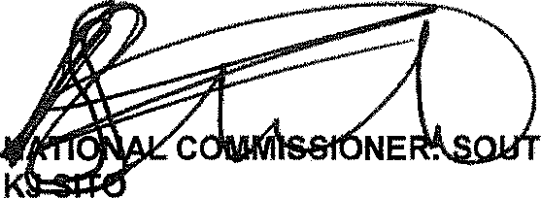
Date: »1g -„- i ,

LE (SOEG)

GENERAL H AFRICAN POLICE SERVICE

2

Reply to question 1786 approved/not approved
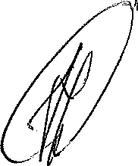
MINISTER OF POLICE BH CELE, P

