FOR WRITTEN REPLY QUESTION 1784

NATIONAL ASSEMBLY
36/1/4/1(201800189)

DATE OF PUBLICATION IN INTERNAL QUESTION PAPER: 1 JUNE 2018 (INTERNAL QUESTION PAPER NO 19-2018)

1784. Mr D America (DA) to ask the Minister of Police:

- What is the current (a) actual and (b) optimal number of police officers involved with sector policing at the Kempton Park Police Station;

by what date will the specified police station receive its full complement of sector police officers?
NW1941E
REPLY:

(1)(a)(b) and (2)

Police Station

Kempton Park Sector Policing

(1)(a) (1)(b)
Actual Optimal (Ideal)

49 65 (-16)

(2)
Date when full complement will be reached
During he 2017/2018 financial year, five students were allocated to the police station. The entry level allocation demand was submitted to the National Commissioner and once the allocation is received, priority will be given to police stations, in order to address shortages and fill the projected service terminations

Reply to question 1784 recommended/

CO
LE (SOEG)
GENERAL ER: TH AFRICAN POLICE SERVICE

2

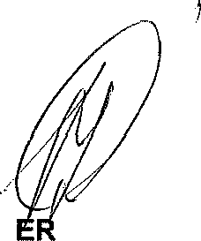
Reply to question 1784 approved/not-

MINIST OF POLICE BH CELE, MP

