FOR WRITTEN REPLY OUESTION 1783

NATIONAL ASSEMBLY
36/1/4/1(201800188)

DATE OF PUBLICATION IN INTERNAL QUESTION PAPER: 1 JUNE 2018 (INTERNAL QUESTION PAPER NO 19-2018)

1783. Mr D America (DA) to ask the Minister of Police:

- What is the current (a) actual and (b) optimal number of police officers involved with sector policing at the Norkem Police Station;

- by what date will the specified police station receive its full complement of sector police officers?

REPLY:

(1)(a)(b) and (2)

Police Station

(1)(a) (1)(b)

(2)
NW1940E

Norkem Park Sector Policing
Actual Optimal (Ideal)

29 23 (+6)
Date when full complement will be reached
During the 2017/2018 financial year, two students were allocated to the olice station.

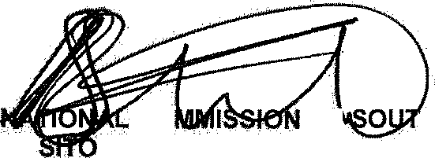
Reply to question 1783 recommended/

CO
KJ LE (SOEG)

Date: ]g'{$ -§§- b &

GENERAL ER! H AFRICAN POLICE SERVICE

2

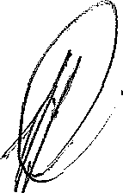
Reply to question 1783 approved/ e

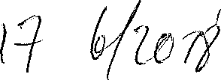
MINISTER OF POLICE BH CELE, MP

Date:

