36/1/4/1(201800187)
NATIONAL ASSEMBLY

FOR WRITTEN REPLY

QUESTION 1782

DATE OF PUBLICATION IN INTERNAL QUESTION PAPER: 1 JUNE 2018 (INTERNAL QUESTION PAPER NO 19-2018)

1782. Mrs A M Dreyer (DA) to ask the Minister of Police:

What is the current (a) actual and (b) optimal number of police officers involved with sector policing at the Germiston Police Station;

- by what date will the specified police station receive its full complement of sector police officers?

REPLY:

(1)(a)(b) and (2)

(1)(a) (1)(b)

(2)
NW1939E

Police Station

Germiston

Actual Optimal (Ideal)
Date when full complement will be reached
During the 2017/2018 financial

Sector Policing 72 51 (+21)
year, seven students were allocated to the police station.

Reply to question 1782 recommended/id

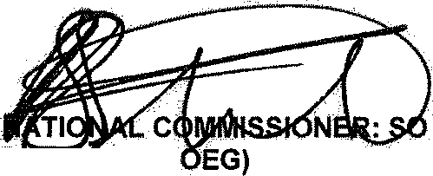
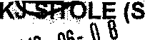
GENERAL UTH AFRICAN POLICE SERVICE

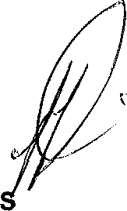
Reply to question 1782 approved/not approved

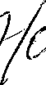
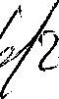
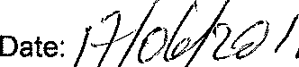
MINI TER OF POLICE BH CELE, MP

