36I1I4I4(201800186)
NATIONAL ASSEMBLY

FOR WRITTEN REPLY

QUESTION 1781

DATE OF PUBLICATION IN INTERNAL QUESTION PAPER: 1 JUNE 2018 (INTERNAL QUESTION PAPER NO 19-2018)

1781. Mrs A M Dreyer (DA) to ask the Minister of Police:

- What is the current (a) actual and (b) optimal number of police officers involved with sector policing at the Elsburg Police Station;

- by what date will the specified police station receive its full complement of

sector police officers?

REPLY:

(1)(a)(b) and (2)

Police Station

(1)(a) (1)(b)

Date when

(2)
NW1938E

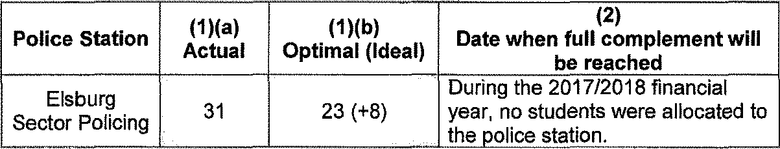
will

Elsburg

Actual Optimal (Ideal)
full complement be reached
During the 2017/2018 financial

Sector Policing 31 23 (+8)

Reply to question 1781 recommended/
year, no students were allocated to the olice tat one

KJ ROLE (SOEG) Date: 8 .,‹- 18
GENERAL TH AFRICAN POLICE SERVICE

Reply to question 1781 approved/not approved

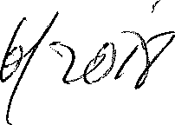
MINIST OF POLICE BH CELE, MP,

Date: "

