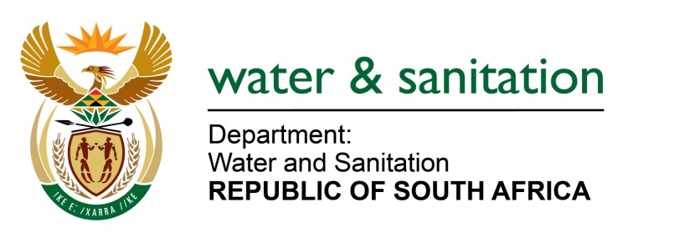

NATIONAL ASSEMBLY

FOR WRITTEN REPLY

QUESTION NO 1779

DATE OF PUBLICATION IN INTERNAL QUESTION PAPER: 9 JUNE 2017
(INTERNAL QUESTION PAPER NO. 21)

1779. Mrs D Robinson (DA) to ask the Minister of Water and Sanitation:
Does (a) she, (b) her Deputy Minister or (c) any of the heads of entities or bodies reporting to her make use of security services paid for by the State for (i) him/herself, (ii) his/her immediate family members or (iii) any of their staff members; in each case (aa) what are the reasons for it, (bb) from which department or entity’s budget is the security services being paid, and (cc) what are the relevant details? NW1985E

---00O00---
REPLY:
(1) The Deputy Minister and myself make use of the security services paid for by the State as provided for by the Ministerial Handbook.
(2) No members of my family, nor those of the Deputy Minister and the Entities reporting to me; have made use of security services paid for by the State. No staff members either of the department or its entities have made use of security services paid for by the State.
---00O00---

