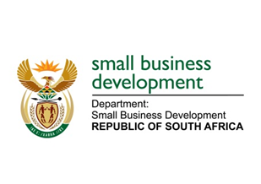
NATIONAL ASSEMBLY
QUESTION FOR WRITTEN REPLY
DUE TO PARLIAMENT: FRIDAY, 26 MAY 2023

“1776. Mr D F Mthenjane (EFF) to ask the Minister of Small Business Development:
How do the Small Enterprise Finance Agency and the Small Enterprise Development Agency deal with the overlaps and duplications in the roles and services they and the North-West Development Corporation offer?” NW2040E

REPLY:
I have been advised:
that the relationship between the Small Enterprise Development Agency (Seda), Small Enterprise Finance Agency (sefa) and the North-West Development Corporation (NWDC) is both strategic and complimentary.

Currently the NWDC does not provide funding to SMMEs in the province, they provide access to finance by linking SMMEs that require business funding with other Development Finance Institutions including, but not limited to, sefa. Additionally, NWDC also provides access to markets and access to industrial infrastructure to SMMEs funded through sefa.

Furthermore, the NWDC offers non-financial support only to the clients that it has previously facilitated access to finance for by linking them with DFIs. In essence the relationship with our agencies is a complementary relationship.

