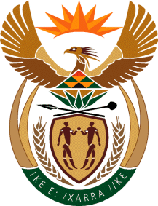
MINISTRY
SPORT AND RECREATION
REPUBLIC OF SOUTH AFRICA

Department of Sport and Recreation l Private Bag X896 l PRETORIA l 0001 l Regent Place l 66 Queen Street l Pretoria l 0001 l +27 (0)12 304 5158 l Fax: +27 (0)12 323 8426
Private Bag X9149 l Cape Town l 8000 l 2nd Floor Parliament Building l 120 Plain Street l CAPE TOWN l Tel: +27 21 469 5705 l Fax: +27 21 465 4402
www.srsa.gov.za
_____________________________________________________________________

NATIONAL ASSEMBLY

WRITTEN REPLY

QUESTION PAPER: No. 21 of 09 JUNE 2017

DATE OF REPLY: 24 JULY 2017

1773. Mr R K Purdon (DA) asked the Minister of Sport and Recreation:
Does (a) he, (b) his Deputy Minister or (c) any of the heads of entities or bodies reporting to him make use of security services paid for by the State for (i) him/herself, (ii) his/her immediate family members or (iii) any of their staff members; in each case (aa) what are the reasons for it, (bb) from which department or entity’s budget is the security services being paid, and (cc) what are the relevant details? NW1979E

______________________________________________________________________
The Minister of Sport and Recreation
REPLY:
Neither (a) myself, (b) the Deputy Minister nor (c) any of the heads of entities reporting to the Minister of Sport and Recreation made use of security services paid for by the State for (i) myself, (ii) my immediate family or (iii) any of the staff members. VIP protection is provided to me and the Deputy Minister by the South African Police Service from the budget of the Department of Police, which is standard for all Ministers and Deputy Ministers.

(aa), (bb) and (cc) fall away.

