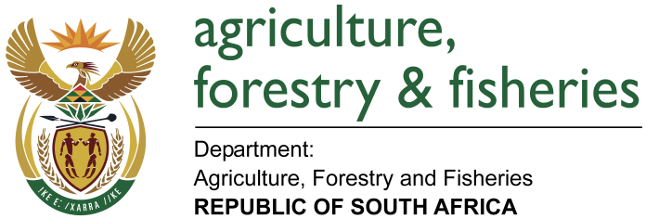
NATIONAL ASSEMBLY

WRITTEN REPLY

QUESTION 177 / NW188E

MINISTER OF AGRICULTURE, FORESTRY AND FISHERIES:
MS A STEYN (DA) TO ASK THE MINISTER OF AGRICULTURE, FORESTRY AND FISHERIES

QUESTION:
Is South Africa currently exporting donkey hides, if so, (a) to which countries and (b) how many hides have been exported to each country? NW188E
REPLY:
- No, South Africa is currently not exporting donkey hides. South Africa does not have any agreement on Health Certificate for exports of donkey skins with any trade partners.

Health requirements are negotiated with trade partners and health certificates (or Protocols) are then agreed to by the two countries’ veterinary services. To date, the Department of Agriculture, Forestry and Fisheries has not engaged with any trade partner in the negotiation of import requirements for donkey skins.
- No skin hides have been officially exported to any trade partners.

