FOR WRITTEN REPLY
QUESTION 1764

NATIONAL ASSEMBLY
36/1/4/1(201800182)

DATE OF PUBLICATION IN INTERNAL QUESTION PAPER: 1 JUNE 2018 (INTERNAL QUESTION PAPER NO 19-2018)
1764. Ms D Kohler (DA) to ask the Minieter of Police:
- What number of SA Police Service (SAPS) officers resigned in each province
  - in each of the past three financial years and (b) since 1 April 2D18;

- what (a) number of SAPS officers resigned from the (i) Mitchells Plain and (ii) Lentegeur Police Station (aa) in each of the past three financial years and (bb) since 1 April 2018 and (b) reasons were put farth in each case?
NW1921E
REPLY:

(1)(a)(b)

Province | (a) 2015/2016 | (a) 2016/2017 | (a) 2017/2018 | (b)  1 April to 1  June 2018
Western Cage | 339 | 187 | 190 | 34
Eastern Cape | 222 | 169 | 183 | 30
Northern Cape | 106 | 61 | 58 | 8
Free State | 131 | 99 | 115 | 19
KwaZulu-Natal | 325 | 207 | 166 | 24
North West | 195 | 122 | 123 | 12
Mpumalanga | 135 | 69 | 70 | 13
Limpopo | 200 | 110 | 95 | 17
Gauteng | 484 | 331 | 294 | 55

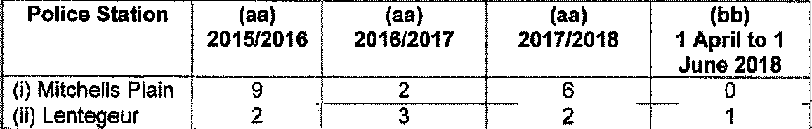
(2)(i)(ii)(aa)(bb)
(ii) Lentegeur
2
3
2
1

Police Station | (aa) | (aa) | (aa) | (bb)
(I) Mitchells Plain | 2015/2016  9 | 2016/2017  2 | 2017/2018 | 1 April to 1  June 2018  0

(2)(i)(b)
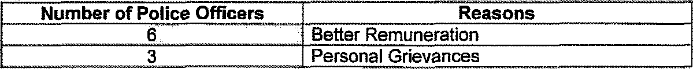
2016/2016
Number of Police Officers 6
3

Reasons Better Remuneration Personal Grievances

201612017
Number of Police Officers
Reasons
Other Occu ation

2017/2018
Number of Police Officers | Reasons
2  2  1  1 | Marriage
 | Nature of work
 | Unhappy about management style
 | Management not assisting members properly

(2)(ii)(b)
2015/2016
Better Remuneration Personal Grievance
2016/2017

2017/2018
t”Réésons put fortfif
Better Remuneration Personal Grievances
”% ?8Nuberf/goli é'.Office11..@ if@B@@ ERéasons‹ ”ut forth
2 Personal Grievances

2018/2019
Reasons p ttforth
Personal Grievance

Original signed LIEUTENANT GENERAL DIVISIONAL COMMISSIONER: PERSONNEL MANAGEMENT L NTSHIEA

Date: 6 June 2O18

Reply to question 1764 recommended/

Orig/na/ signed LIEUTENANT GENERAL DEPUTY NATIONAL COMMISSIONER: HUMAN RESOURCE IgANAGEMENT BC MGWENYA

Date: 6 June 2018
Reply to question 1764 recommended/not recommended

AL
KJ SITOLE (SOEG)
Date: ›› JUN 2»‹
GENERAL SOUTH AFRICAN POLICE SERVICE

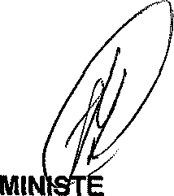
Reply to question 1764 approved/ éd

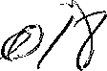
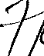
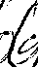
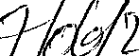
R OF POLICE BH CELE, MP

Date:

