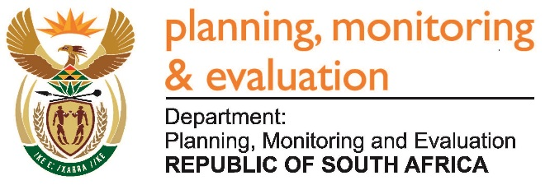 |  | 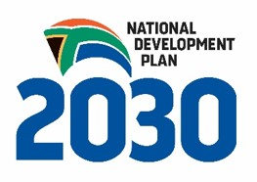
Private Bag X944, PRETORIA, 0001. Union Buildings East Wing, Government Avenue, PRETORIA
Tel: 012 312 0307. www.dpme.gov.za

1764. Mr T W Mhlongo (DA) to ask the Minister in The Presidency:
Does (a) he, (b) his Deputy Minister or (c) any of the heads of entities or bodies reporting to him make use of security services paid for by the State for (i) him/herself, (ii) his/her immediate family members or (iii) any of their staff members; in each case (aa) what are the reasons for it, (bb) from which department or entity’s budget is the security services being paid, and (cc) what are the relevant details? NW1970E
REPLY:
Security for the Minister and the Deputy Minister is provided by the South African Police (Protection and Security Service) as provided for in the Ministerial Handbook.

