FOR WRITTEN REPLY QUESTION 1763

NATIONAL ASSEMBLY
36/1/4/1(201800181)

DATE OF PUBLICATION IN INTERNAL QUESTION PAPER: 1 JUNE 2018 (INTERNAL QUESTION PAPER NO 19-2018)

1763. Ms D Kohler (DA) to ask the Minister of Police:

(a) Which provinces are currently experiencing shortages of bullets whlch in turn have resulted In the inability of SA Police Service officers to undertake their firearm competency practice and tests, (b) how much ammunition should be stored at each police station for this purpose and (c) whlch stations have a shortage which has led to the stoppage of all firearm training?

REPLY: (1)(a)

(1)(b)(c)
NW1920E

The following provinces are currently experiencing shortages of ammunition, specifically with regard to firearm training:
-+ Eastern Cape.
••+ Gauteng.
-+ KwaZulu-Natal.
--+ Mpumalanga.
-+ North West.
-+ Western Cape.

Police stations are not responsible for firearms training and therefore, do not present firearm training to their members. The ammunition that police stations have on hand, is specifically to provide for thelr day-ta- day operational needs. Police Stations have adequate ammunition for this purpose.

Reply to question 1763 recommended/

GENERAL
AL SS 1SOUTH AFRICAN POLICE SERVICE KJ SfTOLE (SOEG)
Date: i ‹ JUN a
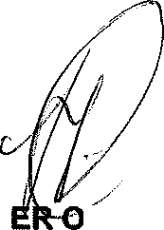
Reply to question 1763 approved/notapp_ygdro

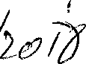
MINIST F POLICE BH CELE, MP
'*

Date:

