FOR WRITTEN REPLY
QUESTION 1762

NATIONAL ASSEMBLY
36/1/4/1(201800180)

DATE OF PUBLICATION IN INTERNAL QUESTION PAPER: 1 JUNE 2018 (INTERNAL QUESTION PAPER NO 19-2018)

1762. Ms D Kohler (DA) to ask the Minister of Police:

- What is the total number of (a) SA Police Service (SAPS) officers who were charged with aiding an escapee in each province (i) in each of the past five financial years and (ii) since 1 April 2018 and (b) such cases that (i) have been withdrawn and/or (ii) are pending;

- (a) what is the total number of SAPS officers who were found (i) guilty and (ii) not guilty of aiding an escapee in each province and (b) what sanctions were taken by his department against the officers who were found guilty?
NW1919E
REPLY:

(1)(a)(i)(ii)

Province |  | (i)  2013/2014 |  | (i)  2014/2015 | (i)  2015/2016 | (i)  2016/2017 | (i)  2017/2018 | (ii) 2018-04-01  to 2018-05-31
Eastern Cape |  | 40 |  | 43 | 54 | 52 | 70 | 1
Free State |  | 19 |  | 37 | 17 | 4 | 14 | 0
Gauten |  |  | 84 | 51 | 57 | 19 | 28 | 8
KwaZulu-Natal |  |  | 48 | 34 | 56 | 45 | 32 | 0
Limpopo |  | 11 |  | 10 | 3 | 3 | 10 | 0
Mpumalanga |  | 29 |  | 44 | 45 | 34 | 36 | 0  0
North West |  | 39 |  | 16” | 35 | 23 | 11
Northern Cape |  | 13 |  | 7 | 11 | 1 | 31 | 0
Western Cape |  | 138 |  | 98 | 111 | 93 | 19 | 0
Total |  | 421 |  | 340 | *89 | 274 | 251 | 9

(1)(b)(i) From 1 April 2018 to 31 May 2018, no cases have been withdrawn.

(1)(b)(ii) From 1 April 2018 to 31 May 2018, all nine cases are still pending.

(2)a)() |  |  | 2
Province | 2013/2014 | 2014/2015 | 2015/2016 | 2016/2017 | 2017/2018
Eastern Ca e | 31 | 39 | 43 | 23 | 23
Free State | 16 | 27 | 15 | 0 | 2
Gauten | 81 | 48 | 43 | 8 | 12
KwaZulu-Natal | 28 | 17 | 31 | 24 | 15
Lim o o | 11 | 3 | 3 | 1 | 8
M umalan a | 23 | 30 | 28 | 28 | 25
North West | 17 | 6 | 14 | 9 | 11
Northern Ca e | 13 | 5 | 3 | 1 | 17
| Western Cape 72 |  | 51 | 37 | 28 | 5
T t 2 2 |  | 2 | 21 | 122 | 118

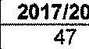
(2)(a)(ii)

Province | 2013/2014 |  | 2014/2015 | 2015/2016 | 2016/2017 | 2017J2018  47
Eastern Cape | 9 |  | 4 | 11 | 29
Free State | 3 |  | 10 | 2 | 4 | 12
Gauteng | 3 |  | 3 | 14 | 11 | 16
KwaZulu-Natal | 20 |  | 17 | 25 | 21 | 17
Limpopo | 0 |  | 7 | 0 | 2 | 2
aMha u a  North West | 6  2 |  | 14 | 17 | 6  14 | 1  0
 |  |  | 10 | 21
NorthernCape | 0 |  | 2 | 8 | 0 | 14
WesternCape | 66 |  | 47 | 74 ” | 65 | 14
Total | ” 129 |  | 114 | 172 | 152 | 133
(2)(b)
2013/2014
Eastern Cape 0
Free State 0
Gautenq 0
KwaZulu-Natal 2
Limpopo 0
Mpumalanqa 0
NorthWest 0
NorthernCape 0
WesternCape 4
Total 6
0
2
7
1
1
0“
0
1
0
12
0
0
0
0
0
0
0
0
9
4
0
1
5
0
,
,
|
10
1
15
3 1
0 2
3 0
2 3
1 2
0 4
1 ’ 0
2 0
20 0
32 12
11
6
28
1
1
4
1
0
9
61
3
0
0
0
0
1
0
0
0
4
9
6
42
14
6
11
5
9
24
126
pagpuadsn
Province
Counselling
Verbal
warning
Written warning
Final written
Suspended without pay
Suspended
sanction

 |  | jgss!=• !a |  |  |  | Xed 1n=9t! papuadsns |  | papuadsng
EasternCape | 0 | 1 | 0 | 10 | 3 | 1 | 12 | 0 | 12
FreeState | 0 | 1 | 0 | 1 | 3 | 0 | 17 | 0 | 5
Gauteng | 0 | 4 | 0 | 1 | 3 | 0 | 17 | 0 | 23
KwaZul-u Natal | 0 | 0 | 0 | 5 | 4 | 2 | 3 | 0 | 3
Limpopo | 0 | 0 | 0 | 1 | 0 | 0 | 0 | 1 | 1
Mpumalanga | 0 | 0 | 0 | 0 | 3 | 7 | 2 | 0 | 18
NorthWest | 0 | 0 | 0 | 3 | 1 | 0 | 0 | 1 | 1
NorthernCape | 0 | 0 | 0 | 1 | 0 | 0 | 0 | 0 | 4
WesternCaoe | 3 | 0 | 1 | 17 | 14 | 0 | 7 | 0 | 9
Total | 3 | 6 | 1 | 39 | 3_1 , | 10 | 58 | 2 | 76

2015/2016
Eastern Cape | 3 ' | 0 | 1 | 3 | 3 1 | 1 1 | 20 i | 0 | 13
Free State | 0 | 1 | 1 | 0 | 2 | 0 | | 6 | 1 | 4
Gauteng | 0 | 5 | 0 | 2 ’ | 7 | 2 | 12 | 0 | , 15
KwaZul-u Natal | 2 | 0 | 0 | 0 | 14 | 0 | 6 | 2 | 7
LiFH DOQ O | 0 | 0 | 0 | 0 | 0 | 0 | 0 | 0 | 3
Mpumalanqa | 0 | 1 | 0 | 0 | 0 ' | 5 | 0 | , 0 | 22  3
NorthWest | 0 | 0 | 3 | 1 | 4 | 0 | 2 | 1
NorthernCape | 0 | 0 | 0 | 2 ' | 0 | , 0 | 0 | 0 | 1
WesternCape | 3 | 0 | 0 | 12 | 9 | 0 ' | 6 | 0 | 7
{Total | 8 | 7 | 5 | 20 | 39 | 8 | 52 | 4 | 75

[
/

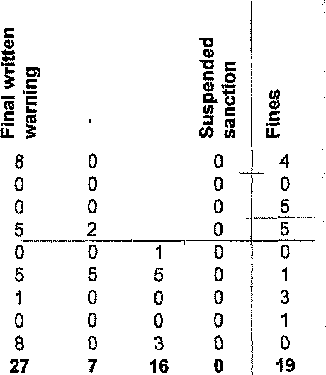
2016/2017
 | su!li• sunog |  |  | BuluJent uen! M |  |  | ‹o A  D  0  e
Eastern Cape | 1 | 1 | 0 | 8 |  |  |  | 1
Free State | 0 | 0 | 0 | 0 |  |  |  | 0
Gauteng | 0 | 0 | 0 | 0
KwaZul-u Natal | 2 | 0 | 0 | 7 |  |  |  | 3
Limpopo | 0 | 0 | 0 | 0
Mpumalanga | 0 | 1 | 8 | 3
North West | 0 | 0 | 0 | 5
Northern Cape | 0 | 0 | 0 | 0
Western Cape | 0 | 1 | 3 | 13
TotaI | 3 | 3 | 11 | 36

L [
]

l
]
/

4

2017/2018 -
without pay
Province | Counselling | Dismissal | Verbal  warning | Wrifien warning |  | Final written | Suspended |  |  | Suspended | Suspended  sanction |  | Fines
EasternCape | 1 | 0 | 0 | 6 |  | 6 | 7 |  |  | 0 | 0 | 2
FreeState | 0 | 0 | 0 |  | 0 | 1 |  | 1 |  | 0 | 0 | O
Gauteng | 0 | 0 | 0 |  | 5 | 6 | "1 |  |  | 0 | 0 | 0
KwaZulu-Natal | 2 | 0 | 0 | 6 |  | 7 | 0 |  |  | 0 | 0 | 0
Limpopo | 0 | 1 | 0 | 1 |  | 4 | 2 |  |  | 0 | 0 | 0
Mpumalanga | 0 | 0 | 0 | 15 |  | 9 | 1 |  |  | 0 | 0 | 0
NorthWest | 0 | 0 | 0 | 9 |  | 2  14 | 0 |  |  | 0 | 0 | 0
NorthernCage | 0 | 0 | 0 | 3 |  |  | 0 |  |  | 0 | 0 | 0
WesternCape | 0 | 0 | 2 | 0 |  | 2 | 1 |  |  | 0 | 0 | 0
Total | 3 | 3 | 2 | 45 |  | 51 | 13 |  |  | 0 | 0 | 2

Reply to question 1762 recommended/

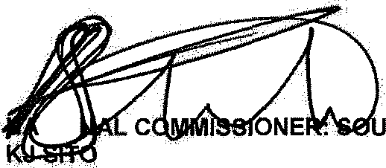
Date: z018 -«- ‹ •
TIO
LE (SOEG)
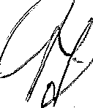
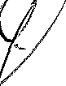
Reply to question 1762 approved/

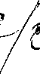
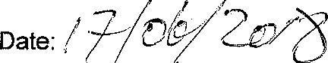
."OF POLICE BH CELE, MP
GENERAL TH AFRICAN POLICE SERVICE

