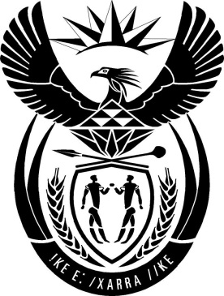

MINISTRY: PUBLIC SERVICE AND ADMINISTRATION

REPUBLIC OF SOUTH AFRICA

NATIONAL ASSEMBLY

QUESTION FOR WRITTEN REPLY

QUESTION NO.: 176.

Dr L A Schreiber (DA) to ask the Minister of Public Service and Administration:
Whether his department intends to conduct the lifestyle audits on all (a) Members of the Cabinet, (b) Deputy Ministers and (c) Directors-General; if not, in each case, why not; if so, (i) what is the state of preparedness for conducting the lifestyle audits, (ii) what are the terms of reference of the audits and (iii) by which date will the terms of reference be made public? NW1134E
REPLY
(a)(b) The DPSA is not mandated to conduct lifestyle audits on members of the Executive, which includes members of Cabinet and Deputy Ministers.
(c) The newly established Public Administration Ethics, Integrity and Disciplinary Technical Assistance Unit (called the “Ethics Enforcement Unit”) is mandated in terms of section 15 of the Public Administration Management Act, 2014 (PAMA), to conduct ethics profiles, which includes lifestyle audits, and includes all employees in the public administration, including Director-Generals.
(i) On 1 April 2019, a proclamation issued in terms of the Public Administration Management Act, 2014 (PAMA 2014) brought into effect the Public Administration Ethics, Integrity and Disciplinary Technical Assistance Unit (the “Ethics Enforcement Unit”).

The mandate of this Unit, in terms of section 15 of PAMA 2014, (see Tag A) is to:
- support and provide technical assistance for the management of ethics, integrity and disciplinary matters relating to misconduct in the public administration;
- develop norms and standards for the above;
- build capacity around the disciplining of misconduct;
- strengthen oversight of ethics, integrity and discipline; and to intervene in cases where systemic weaknesses are identified;
- promote ethics and integrity; and
- cooperate with other institutions and organs of state.

As such, this Unit is the legal custodian of all integrity testing information and is responsible for lifestyle audits and integrity testing in all spheres of government.

The Unit is currently incubated in the DPSA, with efforts underway to fund and staff it properly, through a process of internal reprioritisation and reorganisation. The first phase will commence from 01 September 2019, and will include lifestyle audits as a function.

ii)-iii) The Unit has identified lifestyle audits as a priority and during its incubation phase will focus on the Public Service. To this effect, the unit has drafted a Framework for conducting lifestyle audits on public service employees. The Framework will be presented for approval to the Minister of the Public Service and Administration, where after terms of reference will be developed. As soon as this is finalised, it will be announced.

End

