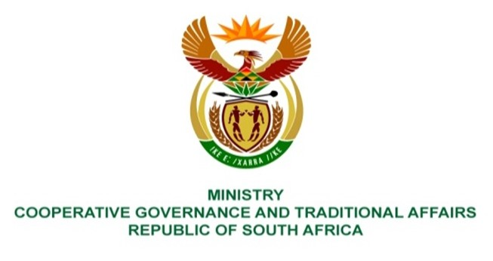

NATIONAL ASSEMBLY
QUESTION FOR WRITTEN REPLY

DATE OF PUBLICATION: 12 MAY 2023

1759. Mrs S M Mokgotho (EFF) to ask the Minister of Cooperative Governance and Traditional Affairs:
By what date will residents of Ward 14 in Moretele be provided with housing as they were promised Reconstruction and Development Programme houses by the Moretele Local Municipality since 2018, but to date the specified municipality has not kept its promise? NW2012E
REPLY:
For the purpose of providing RDP homes, the municipalities collaborate closely with the department of Human Settlement. It is advised that the Ministry of Human Settlement receive this inquiry in order to receive appropriate answers.
End.

