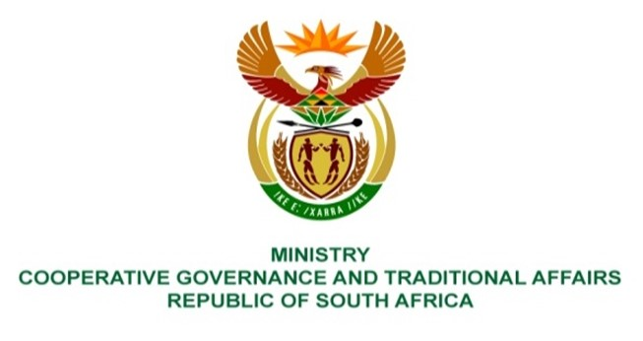

NATIONAL ASSEMBLY
QUESTION FOR WRITTEN REPLY

DATE OF PUBLICATION: 12 MAY 2023

1758. Mrs S M Mokgotho (EFF) to ask the Minister of Cooperative Governance and Traditional Affairs:
By what date is it envisaged that residents of Thabazimbi in Limpopo, who are currently without water, will be provided with adequate water supply by the Thabazimbi Local Municipality? NW2011E
REPLY:
For the provision of water, the municipalities collaborate closely with the department of Water and Sanitation.
End.

