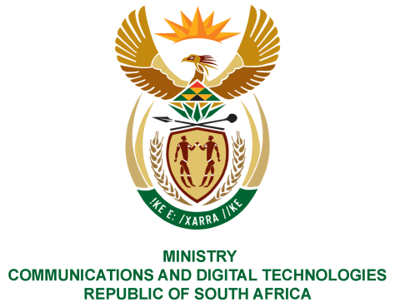

PARLIAMENT OF THE REPUBLIC OF SOUTH AFRICA

NATIONAL ASSEMBLY

WRITTEN REPLY

QUESTION NO: 1756

Mr C MacKenzie (DA) to ask the Minister of Communications:

(1) Whether certain radio licence holders (names and details furnished) have been invoiced for annual radio licence fees by the Independent Communications Authority of South Africa for the current year; if not, by what date will the invoicing be done;

(2) What (a) is the total number of radio licence holders that require annual invoices and (b) number of the specified radio licence holders have been invoiced for annual licence fees for 2020?
NW2146E

REPLY:

I have been advised by ICASA as follows:

1. All invoices for the annual Radio Frequency Spectrum (RFS) licence fees for a total of 20,795 RFS licences for the 2020-21 financial year have been issued. This figure includes the licenses held by Monitoring, District Watch and District Bassett and all invoices were finalised and issued by 22 July 2020.

2. (a) A total number of 20 795 radio frequency spectrum licence holders require annual invoices.
(b) All Invoices were finalised and issued. The total amount invoiced for the annual RFS licence fees is R 741, 258, 948.00. The Authority extended the 2020 annual licence renewal date of RFS licences from 31 March 2020 to 30 June 2020 to mitigate the impact of the National State of Disaster and subsequent national lockdown on licensees. This was communicated on the Authority’s website in March 2020 and subsequently published in Government Gazette No. 43204 dated 3 April 2020. The Authority notes that the COVID-19 pandemic has had an impact on the day to day operations of the Authority which resulted in some licensees receiving their notices in July. Affected licenses will, however not be penalised and measures have been put in place to ensure that the renewed licences are issued timeously.

MS. STELLA NDABENI-ABRAHAMS, MP
MINISTER OF COMMUNICATIONS AND DIGITAL TECHNOLOGIES

