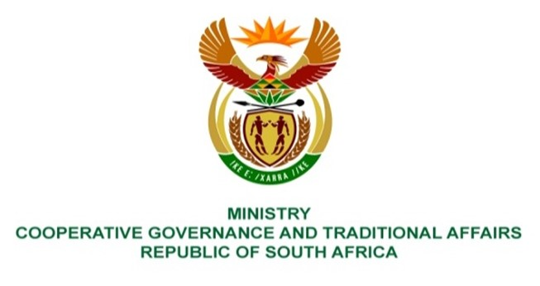

NATIONAL ASSEMBLY
QUESTION FOR WRITTEN REPLY

DATE OF PUBLICATION: 12 MAY 2023

1753. Ms R N Komane (EFF) to ask the Minister of Cooperative Governance and Traditional Affairs:
Considering how contracts of implementing agents of the Community Work Programme were terminated on 31 March 2023 while the participants have not yet signed their annual employment contracts, and noting that most of the participants have not been paid their April stipend and that no communications have been made with them, how does her department ensure (a) timeous payments and (b) supervision of the specified programme? NW2001E
REPLY:
- The contracts of the Implementing Agents (IA)were not terminated, they expired as per Service Level Agreement with the department. The department is finalising the contracting of site staff (it should be noted that some of the implementing agents did not terminate the contracts of the site staff upon IA contract expiration and this led to delays in finalising the site staff contracting. Communication of delay in April payments was sent to the participants via sms. The participant payments for April are currently sitting at 99.9% as at 15May 2023. The 0.1% relates to errors in Timesheets which have been referred back to sites for correction. The department has augmented capacity in Payment unit and are already receiving training and this will expedite the payment process.
- The department has contracted Provincial Managers, District Managers and Site Managers who are supervising the programme. Furthermore, there is provincial and national COGTA capacity (Chief Directors and Directors for each province) who are playing an oversight role. The Local Reference Committees are also in existence to provide support in terms of CWP implementation at ward level.
End.

