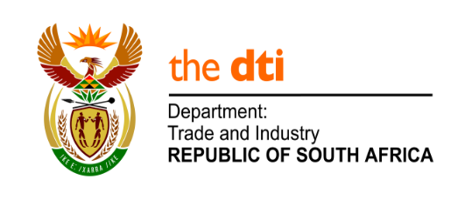

NATIONAL ASSEMBLY

WRITTEN REPLY

PARLIAMENTARY QUESTION 175

DATE OF PUBLICATION: 29 JULY 2019
Mr K J Mileham (DA) to ask the Minister of Trade and Industry:
Whether the Government subsidises in any way the (a) import and/or (b) production of electric vehicles; if not, why not in each case; if so, in each case, what (i) are the relevant details, (ii) number of companies involved in the import or production of electric vehicles receive such subsidies and (iii) is the current volume of electric vehicles (aa) produced locally and (bb) imported?

Reply
Support for the importation and production of motor vehicles, under which electric vehicles would ordinarily fall, is covered under the Automotive Production and Development Program (APDP).
Under the APDP, light motor vehicles including electric vehicles can be imported into the country with the use of rebate credit certificates earned. Such certificates allow the importer to offset import duties, where the importer assembles vehicles locally. This incentivizes the development and expansion of vehicle production in South Africa.
The Department advises that fewer than 1 000 electric vehicles have been imported to date; and no auto manufacturer currently assembles electric or hybrid vehicles in South Africa.

I am in discussion with the automobile sector in South Africa regarding the production of electric or hybrid vehicles locally. We are keen to ensure that South Africa develops production capacity in what is anticipated to be a growing part of the car market. On conclusion of the discussions, a formal statement will be made.

-END-

