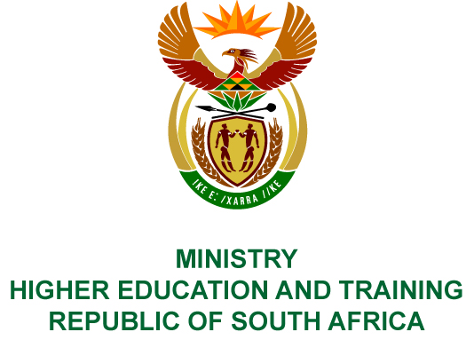
Private Bag X893, Pretoria, 0001, Tel: 012 312 5555, Fax: 012 323 5618
Private Bag X9192, Cape Town, 8000, Tel: 021 469 5150, Fax: 021 465 7956
MEMORANDUM FROM THE PARLIAMENTARY OFFICE
NATIONAL ASSEMBLY
FOR WRITTEN REPLY
QUESTION 175
DATE OF PUBLICATION OF INTERNAL QUESTION PAPER: 15/02/2019
INTERNAL QUESTION PAPER NO 02 OF 2019
Prof B Bozzoli (DA) to ask the Minister of Higher Education and Training:
(1) With reference to the reply to question 647 on 11 April 2018 regarding the Rules and Guidelines for the Administration and Management of the Department of Higher Education and Training’s Technical and Vocational Education and Training College Bursary Scheme, which was to be completed by no later than 30 September 2018, what led to the specified document only being released to technical and vocational education and training (TVET) colleges on 14 December 2018;
(2) has she found that the late release and downward changes in amounts when comparing the specified document with an earlier draft that was circulated, created risks for the management of budgets and learner-relationships at our public TVET colleges; if so, what are the relevant details;
(3) what new steps will her department introduce to prevent a re-occurrence of the continued late release of this important document to TVET colleges;
(4) whether she will be monitoring adherence to the plans in this regard in 2019; if not, why not; if so, what are the relevant details? NW184E
REPLY:
- The Department was exploring the possibility of converting the bursary tuition amount into a conditional grant to minimise the bursary administrative processes, which would have had an impact on the 2019 Bursary Rules and Guidelines. However, it was not possible to implement this for the 2019 academic year. In addition, the process of introducing standardised allowances for Technical and Vocational Education and Training (TVET) colleges were also protracted.
- The Department introduced a new category of allowance, i.e. a personal care allowance, for all bursary recipients to assist them with their necessities. The introduction of standardised allowances and a new category of allowance changed the amounts that were initially considered for travel and accommodation contained in the draft version that was sent out to colleges for their comments.
The Department, in collaboration with the National Student Financial Aid Scheme (NSFAS), had numerous engagements with Principals and financial aid practitioners towards the end of 2018 and beginning of 2019 to prepare for the administration of bursaries. In addition to the ongoing engagements with colleges, the Department also issued Circulars to all colleges which set out the immediate and key steps that colleges had to follow to ensure a smooth 2019 bursary application process.
- Preparing the draft guideline documents for my approval by June at the latest.
- Engagements with college Principals and Student Representative Councils will start in June 2019 to finalise the 2020 Bursary Rules and Guidelines, which the Department aims to release early in October 2019. Concluding all of these activities timeously will allow colleges and students to focus on teaching and learning rather than on student financial aid matters.

