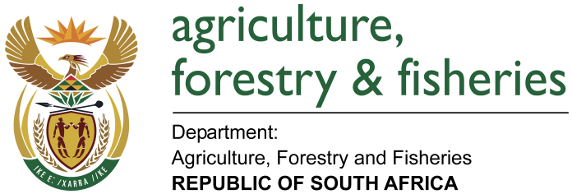
NATIONAL ASSEMBLY

WRITTEN REPLY

QUESTION 1746 / NW1952E

MINISTER OF AGRICULTURE, FORESTRY AND FISHERIES:
1746. Mr T R Majola (DA) to ask the Minister of Agriculture, Forestry and Fisheries:

QUESTION:
Does (a) he, (b) his Deputy Minister or (c) any of the heads of entities or bodies reporting to him make use of security services paid for by the State for (i) him/herself, (ii) his/her immediate family members or (iii) any of their staff members; in each case (aa) what are the reasons for it, (bb) from which department or entity’s budget is the security services being paid, and (cc) what are the relevant details? NW1952E

REPLY:
DAFF
(a) Minister and, (b) Deputy Minister are protected by South African Police Service VIP Protection Unit paid for by State as per Ministerial Handbook.

No immediate staff members at the Department of Agriculture, Forestry and Fisheries are making use of security services paid for by the State.

PPECB
The PPECB has not made use of security services paid for by the State for any of its heads or their family members.

OBP
OBP has never made use of the security services paid for by the State.

NCERA
No CEO, immediate family members nor staff members at Ncera Farms are making use of security services paid for by the State.

ARC
No CEO, immediate family members nor staff members at Agricultural Research Council (ARC) are making use of security services paid for by the State.

NAMC
No CEO, Chairperson, immediate family members nor any staff member of the NAMC are making use of security services paid for by the State.

MLRF
No Deputy Director-General: Fisheries Management, immediate family members nor staff members at MLRF are making use of security services paid for by the State.

