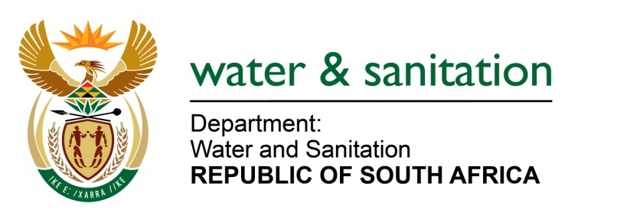

NATIONAL ASSEMBLY

FOR WRITTEN REPLY

QUESTION NO 1744

DATE OF PUBLICATION IN INTERNAL QUESTION PAPER: 9 JUNE 2017
(INTERNAL QUESTION PAPER NO. 21)

1744. Mr C MacKenzie (DA) to ask the Minister of Water and Sanitation:
Whether any staff of (a) her department and (b) each entity reporting to her were awarded any contracts or agreements to conduct business with any state entity in the (i) 2014-15, (ii) 2015-16 and (iii) 2016-17 financial years; if so, what are the (aa)(aaa) names and (bbb) professional designations of the staff members and (bb)(aaa) details of the contract(s) and/or agreement(s) awarded and (bbb) amounts in each case? NW1950E
---00O00---
REPLY:
(a) No staff within my Department were awarded contracts or agreements to conduct business with any state entity within the 2014/15, 2015/16 and 2016/17 financial years.
(b) Refer to Annexure A for the entity reporting to me that were awarded contracts or agreements to conduct business with any state entity in the years mentioned.
---00O00---

