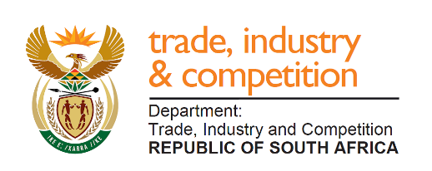

THE NATIONAL ASSEMBLY
QUESTION FOR WRITTEN REPLY
PARLIAMENTARY QUESTION 1738
1738. Mr M J Cuthbert (DA) to ask the Minister of Trade and Industry:
(1) Whether, with reference to his reply to question 567 on 16 September 2019, the Chief Director who had been suspended for 729 days was placed on suspension for dealings in information technology (IT) procurement with a certain company (name furnished);
(2) what are the relevant details of the IT contract in terms of (a) costs, (b) procurement processes and (c) date on which the contract was awarded;
(3) on what statutory grounds did his department rely when charging the Chief Director with fraud? NW3139E

Reply

The Director-General of the Department of Trade and Industry has advised that the disciplinary matter is currently due to be heard through arbitration at a sitting scheduled for 16-17 January 2020, and some of the issues raised in the question may be the subject of dispute. Accordingly, to avoid prejudice in the matter, a fuller reply may be provided on conclusion of the current processes. Subject to the above, I am advised as follows:

The suspension relates to matters involving EOH Mthombo.
The original bid of EOH Mthombo amounted to R20 271 065.83 and was increased to R22 081 065.83 during September 2016. the dti only processed and made five (5) payments to the total amount of R11 154 846.47 as per deliverables. The remaining sum was the subject of a dispute and the Department has not paid this to EOH Mthombo.

Disciplinary action against employees are done in accordance with applicable laws and internal Departmental policies.
-END-

