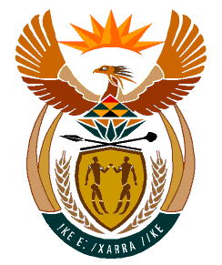

MINISTRY
HUMAN SETTLEMENTS
REPUBLIC OF SOUTH AFRICA

Private Bag X645, Pretoria, 0001. Tel: (012) 421 1309, Fax: (012) 341 8513

Private Bag X9029, Cape Town, 8000. Tel (021) 466 7603, Fax: (021) 466 3610

NATIONAL ASSEMBLY
QUESTION FOR WRITTEN REPLY
QUESTION NUMBER: PQ 1736: NW1979E
DATE OF PUBLICATION: 12 MAY 2023

PQ 1736. Mr S.S. Zondo (IFP) to ask the Minister of Human Settlements:
Since electric geysers are usually the highest electricity-consuming appliances in homes accounting to 30% to 40% of electricity used, what are the full details of the (a) roll-out of solar geysers to date, (b) feedback on their effectiveness of the specified geysers to date and (c) (i) plans and (ii) time frames of the roll-out of solar geysers going forward? NW1979

Reply:
- The provision and roll-out of solar geysers is undertaken by the Department of Mineral Resources and Energy (DMRE) and the National Department of Human Settlements (NDHS) is collaborating with the DMRE in this regard.

To respond to the rising cost of living and energy poverty, I have announced that subsidised houses will be provided with solar panels in all new housing projects at 500W per housing unit. This is effective from the 1st of April 2023. At 500W, this home solar system is envisaged to cover lighting and provide energy to basic home appliances such as radio, television, Wi-Fi and refrigerator. Through this intervention, it is expected that the subsidised home solar system will contribute to the reduction of the total cost of electricity-consuming appliances in homes.

- The NDHS has not rolled out any solar geysers, therefore it cannot provide feedback on the effectiveness thereof.

- (i) The NDHS has held discussions with the Department of Mineral Resources and Energy (DMRE) which are envisaged to culminate into a collaboration that will be expressed in a Memorandum of Agreement, for the installation of 6000 solar geysers in the Eastern Cape province.
c) (ii) The time frames for the roll-out of the solar geysers is expected to take place within the 2023/24 and 2024/25 financial years and will be confirmed in the Memorandum of Agreement between the two Departments.

