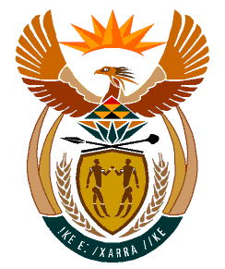

MINISTRY
HUMAN SETTLEMENTS
REPUBLIC OF SOUTH AFRICA

Private Bag X645, Pretoria, 0001. Tel: (012) 421 1309, Fax: (012) 341 8513

Private Bag X9029, Cape Town, 8000. Tel (021) 466 7603, Fax: (021) 466 3610

NATIONAL ASSEMBLY
QUESTION FOR WRITTEN REPLY
QUESTION NUMBER: 1730 [NW1973E]

DATE OF PUBLICATION: 12 MAY 2023

Ms S A Buthelezi (IFP0 to ask the Minister of Human Settlements:

(a) Whether, noting that the 2024 elections are looming, she intends to hand over title deeds as she did in August 2021 shortly before the Local Government Elections were held; if not, what is the position in this regard; if so,

(b) whether any similar projects were completed between the last elections and the upcoming elections during the so-call off-elections seasons, if not, why not; if so, what are the relevant details?

Reply

- The Title Restoration Project is an ongoing project of the government that aims to restore ownership to beneficiaries of state-subsidised houses, that have since 2016 consistently been planned and budgeted for, in the annual provincial business plans.

- It is the department’s policy to hand over title deeds to beneficiaries as soon as possible to avoid loss or damage. The issuing of title deeds by political heads depends on their priorities and availability.

The Minister of Human Settlements will thus continue to issue title deeds to beneficiaries as part of the ongoing work of government, depending on her availability and priorities.

