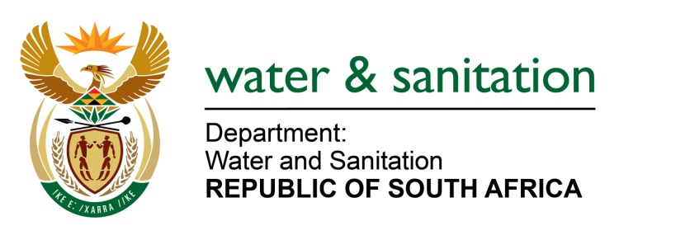

NATIONAL ASSEMBLY

FOR WRITTEN REPLY

QUESTION NO 1729

DATE OF PUBLICATION IN INTERNAL QUESTION PAPER: 12 MAY 2023
(INTERNAL QUESTION PAPER NO. 16)

1729. Ms S A Buthelezi (IFP) to ask the Minister of Water and Sanitation:
Whether he has found that the Government is now better prepared to deal with natural disasters such as the floods in KwaZulu-Natal and Gauteng, which prompted him to call for a state of disaster to be declared in parts of Gauteng which have been hit by floods; if not, what is the position in this regard; if so, (a) how and (b) what are the further relevant details? NW1972E
---00O00---

MINISTER OF WATER AND SANITATION

The intensity of the flood conditions has necessitated a review of the operating rules for government water schemes to ensure that there is some level of attenuation in the impoundment areas of large dams. Cognisance is taken of the changes in weather patterns caused by climate change. The department is putting in place flood mitigation operation strategies to ensure readiness to mitigate the impact of floods in the large dams and other government schemes. Notwithstanding the efforts of the department, there will still be risks where extreme weather conditions result into peak surface runoff over concentrated areas, since this could result in flood conditions within a very short period.

- In urban areas, it will be required from municipal town planning units to review stormwater conveyance capability as well as to maintain such systems to reduce the impact of such rainfall.

- The Department’s Water Resource Planning unit is collecting information which will assist with the review of operating rules to further mitigate the risk associated with flood related peak flows.

---00O00---

