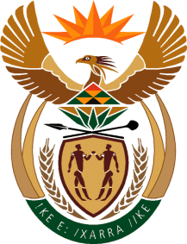

MINISTRY OF TOURISM
REPUBLIC OF SOUTH AFRICA

Private Bag X424, Pretoria, 0001, South Africa. Tel. (+27 12) 444 6780, Fax (+27 12) 444 7027
Private Bag X9154, Cape Town, 8000, South Africa. Tel. (+27 21) 469 5800, Fax: (+27 21) 465 3216

NATIONAL ASSEMBLY:

QUESTION FOR WRITTEN REPLY:
Question Number: 1729
Date of Publication: 4 June 2021
NA IQP Number: 16
Date of reply: 13 JUNE 2021

Ms H S Winkler (DA) to ask the Minister of Tourism:
(a) Where is the Head Office of SA Tourism located, (b) what is the office’s (i) commercial grade and (ii) square meterage and (c) who owns the building in which the Tourism Head Office is located? NW1940E

REPLY:
(a) Bojanala House
90 Protea Road, Cnr Impala and Protea,
City of Johannesburg,
Sandton,
2196
Gauteng Province

- (i) Zoning - Business 4 Offices as per Town Planning Regulations
- Extent of property is 5 345.00 m². Gross building area including ground floor, first floor, basement, covered
patios, balconies, guardhouse and refuse area is 6 025.00 m².

- The building is owned by the South African Tourism Board.

