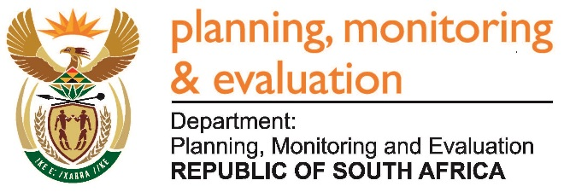 |  | 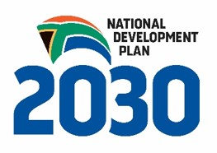
Private Bag X944, PRETORIA, 0001. Union Buildings East Wing, Government Avenue, PRETORIA
Tel: 012 312 0307. www.dpme.gov.za

1729. Ms S P Kopane (DA) to ask the Minister in The Presidency:
Whether any staff of (a) his department and (b) each entity reporting to him were awarded any contracts or agreements to conduct business with any state entity in the (i) 2014-15, (ii) 2015-16 and (iii) 2016-17 financial years; if so, what are the (aa)(aaa) names and (bbb) professional designations of the staff members and (bb)(aaa) details of the contract(s) and/or agreement(s) awarded and (bbb) amounts in each case? NW1935E
REPLY:
No.

