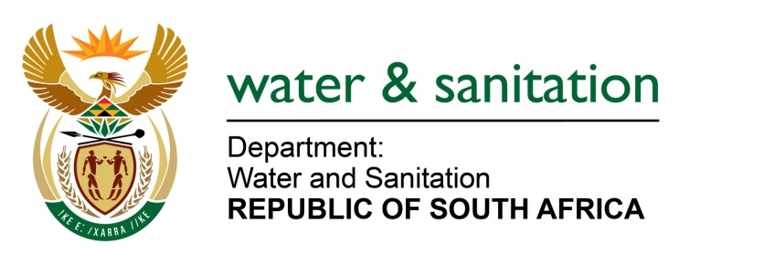

NATIONAL ASSEMBLY

**FOR WRITTEN REPLY**

**QUESTION NO 1722**

**DATE OF PUBLICATION IN INTERNAL QUESTION PAPER: 26 AUGUST 2016**

**(INTERNAL QUESTION PAPER NO. 23)**

**1722. Ms N K Bilankulu (ANC) to ask the Minister of Water and Sanitation:**

(a) What progress has been made with regard to the Bucket Eradication Programme in the provinces where the specified programme has not been fully implemented and (b) what are the reasons for the delay in the completion of the specified programme? NW1972E

---00O00---

**REPLY:**

(a) The Bucket Eradication Programme is being implemented in the Northern Cape, Free State, North West and Eastern Cape Provinces, and the progress is indicated in the table below:



(b) Below are reasons for the delay in the completion of the specified programme:

* Extreme difficult soil conditions exist in the Northern Cape with moderate conditions in the Free State Province which requires sophisticated machinery to enable the excavation of the rock formations;
* In some towns, the extent of the sewer and water reticulation is in excess of 50km which with some difficult soil conditions slows the excavation process;
* Due to the flat terrain of some projects, deep excavations for services, often as deep as 3m must be excavated to ensure gravity flows once connected;
* Disruptions of existing services (due to excavations without drawings or designs of where existing services are located) such as water and electricity in some projects necessitate stoppages so as to restore the service before commencement.
* The non-availability of materials (toilet structures, pipelines for water and sewer, conservancy tanks) have posed an additional delay in terms of acquiring such from suppliers often outside of the province;
* Community protests or disputes over daily labour rates have delayed the project in some provinces for up to 3 weeks at a time.

---00O00---