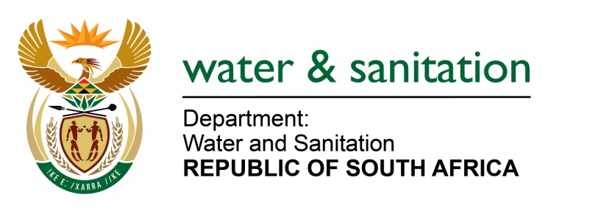

NATIONAL ASSEMBLY

FOR WRITTEN REPLY

QUESTION NO 1721

DATE OF PUBLICATION IN INTERNAL QUESTION PAPER: 26 AUGUST 2016
(INTERNAL QUESTION PAPER NO. 23)

1721. Ms N K Bilankulu (ANC) to ask the Minister of Water and Sanitation:
(a) What progress has been made with regard to the Nooitgedacht Low Level Scheme Phase 2 project which is intended to augment water supply and alleviate water scarcity at the Nelson Mandela Bay Metropolitan Municipality (NMBM) and (b) what are the challenges that have been encountered with regard to completing the project? NW1971E
---00O00---
REPLY:
(a) Phase 2: This phase is fully funded by the NMBM. It entails the construction of an extension of the Nooitgedagt Water Treatment Works (Civil works) on the Western side, all Mechanical and Electrical work associated with the civil works and a new Pump Station. All the work is under construction and approximately 60% completed. This phase should be finished by end of June 2017.
Phase 3: This phase is fully funded by my Department. It entails an extension of the Nooitgedagt Water Treatment Works (Civil works) on the Eastern side (Augmentation of the WTW's by 70Ml/day), all Mechanical and Electrical work associated with the civil works, a new 45Ml Reservoir at Olifantskop, Cathodic Protection and AC mitigation on all bulk lines as well as the rehabilitation of the Chelsea Motherwell pipeline. All the work has gone out on tender which closes on Friday 2 September 2016. All the evaluation and adjudication processes will then follow and it is expected to appoint a contractor by end of October 2016 after which site establishment and construction should start. It will be a 24 months construction period and the anticipated completion date is December 2018.
(b) Phase 2: The only challenges experienced in this phase were rain delays. No further challenges were experienced.
Phase 3: One of the challenges experienced was the signing of a Tri-Partite agreement between the Implementing Agent, Amatola Water, (Appointed by the DWS), DWS and the NMBM. This should however be solved in due course.
Another challenge which caused a delay was the decision of the tender processes on whether to put the work out on different tenders since the work requires different disciplines and skills and/or whether all the work should go out as one tender. The decision was to put it out on one tender which as mentioned above is closing on Friday 1 September 2016.
---00O00---

